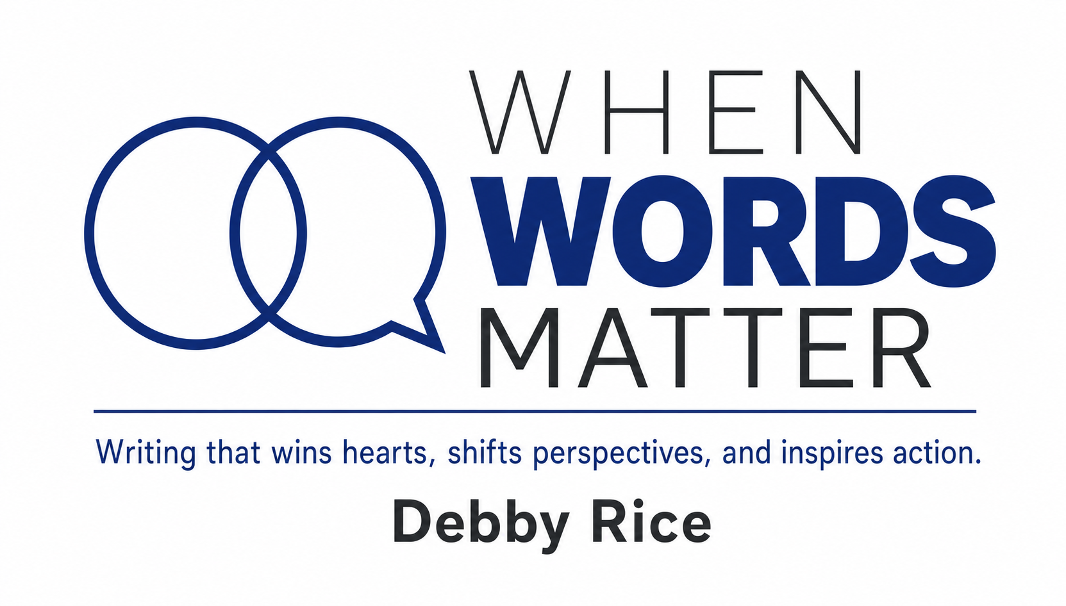
WHEN YOU INVEST IN MY SKILLS, YOU GET—
A strategic approach and communications that drive results. Stronger relationships, partnerships, and networks. A big picture thinker with an eye for detail — and a creative, energetic, and inquisitive teammate.
EXPERIENCE
Freelance Writer
When Words Matter
October 2017–Present
Portfolio: debbyrice.writerfolio.com
I create persuasive content for corporate and nonprofit organizations, including winning grant proposals, inspirational campaign communications, and informative content of all stripes.
Selected clients:
• AB Marketers • Hypertext Magazine and Studio
• American Academy of Implant Dentistry Fdn • i.c.stars
• American Academy of Home Care Medicine • Open Studio Project
• American Academy of Periodontology Fdn • .orgCommunity
• American Planning Association • .orgSource
• BKA Content • The Harbour
• Chicago Public Art Group • Study.com
• FlaxAssociates
Assistant Executive Director for Development / Manager for Development
American Association of Endodontists Foundation, Chicago
June 2000–March 2017 | January 1996–February 1999
Managed over $1 million in annual fundraising activities and $1 million in annual grantmaking initiatives. Growing the foundation’s assets from $1 million to $31 million during my tenure. Oversaw a $31 million investment fund, facilitated Board of Trustees activities, prepared the annual budget, and organized strategic planning. Developed financial, fundraising, and grantmaking goals, policies, and procedures. Managed communications and supervised staff.
Executive Director
The Parkways Foundation, Chicago
February 1999–June 2000
Served as administrator of a new foundation supporting capital improvements in the Chicago Park District. Coordinated board activities and an auxiliary of 100 prominent Chicago women. Managed a $1.5 million campaign to build a Children's Garden at Garfield Park Conservatory. Developed communications, including newsletters, grant proposals, and brochures. Served as liaison to the Chicago Park District's Board of Commissioners and supervised staff.

Director of Development and Public Relations
Volunteers of America of Illinois, Chicago
October 1991–January 1996
Directed fundraising and public relations for this child welfare agency. Coordinated foundation and corporate solicitation, major gifts, annual campaign, and direct mail programs. Produced internal and external communications, including grant proposals, employee newsletters, agency newsletters, and annual reports. Served as development representative to the board, prepared and monitored the development budget, and supervised staff.
EDUCATION
Bachelor of Arts, English — University of Illinois at Chicago
RECOGNITION
Hermes Gold Creative Award, .orgSource Blog 2021
Association Universe MVP Award, 1st Place — Association Management Category 2020
MarCom Gold Award, Focus Newsletter 2017
MarCom Gold Award, Focus Newsletter 2016
MarCom Gold Award, Focus Newsletter 2015
INTERESTS AND ACTIVITIES
Reading and writing fiction, cooking and learning about food and wine, entertaining friends and family, yoga, and other types of exercise.

