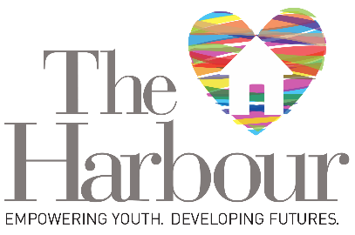
The Harbour Light
Dear Friends:

Flipping the calendar to a new year is a reminder of the hope and possibility that come with a fresh start. I want youth at The Harbour to see their time with us as that new beginning. I am constantly amazed by their resilience and their ability to thrive despite the obstacles that homelessness places on their journeys. We strive to help them continue growing the strengths that empower positive change.
The Harbour offers youth more than a safe place to live. Our house is a home where our staff guides young people to be their best selves. We believe that, with compassion and support, our residents can turn adversity into accomplishment. Our Youth Leadership Award affirms that potential.
Kaylyn Ahn, the 2025 recipient, is an example of how with passion, perseverance, and determination young people can use the challenges they confront to create purpose and opportunity in their lives. Kaylyn’s is an inspirational story that demonstrates the impact one person can make on their own future and the lives of others who encounter similar circumstances.
The award ceremony takes place on March 20 at the Chateau Ritz in Niles. Purchase your tickets at this link. Get a sneak peek at our exciting venue here. We hope you’ll join us at this annual benefit event. Your support for The Harbour is greatly appreciated.
Best wishes for 2025,
Melody Rose
Executive Director
Kaylyn Ahn—2025 Youth Leadership Award Recipient
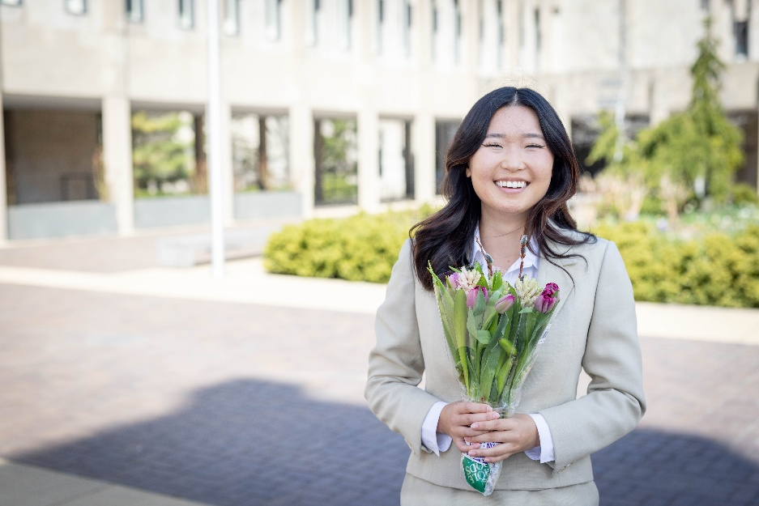
Kaylyn Ahn’s resume boasts achievements that would be impressive for someone twice her age. This Northwestern University senior recently won a Marshall Scholarship, which will provide her with the funding to study for a Master’s Degree in Science and Public Policy at Oxford University in England. She also received a $30,000 Truman Scholarship to support her future legal studies. See the sidebar for a summary of Kaylyn’s many academic and volunteer achievements.
Kahlyn Ahn
Kaylyn’s success has not come without an equal amount of hardship. The winter of her return home from the first quarter at Northwestern, Kaylyn’s mother took her aside to confide a devastating secret. The pattern of domestic abuse in their family was escalating. She urged Kaylyn to leave home, warning her that she was not safe.
Homeless on Campus
“That winter, I became homeless,” Kayln recalls. “I learned that campus financial aid and housing policies do not account for students with unsafe home environments. I moved six times and lived in over 13 different places. During the winter break, I couch surfed with those willing to let me sleep in their living rooms. In the summer, I lived in a moldy, hot closet for $250 a month and became so sick I couldn’t eat for days.”

After a long struggle to retrieve documentation from her estranged parents, the university granted Kaylyn status as a homeless and unaccompanied youth, and she was able to receive financial aid. An op-ed she wrote describing this experience was published in the Daily Northwestern.
After reading that article, a concerned Harbour staff member emailed Kaylyn to offer help. By that time, Kaylyn had secured housing. Her high school English teacher’s family was also offering shelter and support. After learning more about The Harbour, Kaylyn was eager to accept an invitation to participate in the newly established Youth Advisory Board.
Serving the Youth Advisory Board
The Youth Advisory Board taps the expertise of the Harbour’s current and former residents, and other interested young people, to advance our mission. The group, which includes representatives of all the organization’s programs, informs policies and explores new ideas. They also have an opportunity to hone their leadership skills.
Kaylyn Ahn
Academic and Volunteer Accomplishments
- Gilman Scholar to Ecuador
- Gay and Lesbian Alliance Against Defamation 2021 list of 20 Under 20 LGBTQ+ Activists.
- Co-president of the Northwestern Undergraduate Prison Education Partnership
- Debarry Civic Scholar
- As a member of Northwestern’s inaugural Emerging Scholars cohort, traveled to Bosnia-Herzegovina and Serbia on an International Senior Thesis Grant from the Buffet Institute for Global Affairs
- Youngest person in history to receive the highest number of votes to the National Organization for Victim Advocacy's Board of Directors
- Interned with KAN-WIN, a nonprofit for Asian survivors of domestic violence
- Worked for the White House Initiative on Asian Americans, Native Hawaiians, and Pacific Islanders
- Worked at the US Special Envoy for Afghan Women, Girls, and Human Rights.
- A Women of Color Advancing Peace, Security, and Conflict Resolution Pipeline Fellow
- Worked in the economic office of the US Diplomatic Mission to South Africa in Pretoria.
- A three-time national finalist qualifier for the National Forensics Association Championships

Kaylyn describes their impact like this. “It's so important to have the people who are affected by a problem leading the initiatives to find solutions. Giving youth leadership roles and a voice in the organization is empowering. The Harbor is amazing, but homelessness and domestic and sexual abuse are tough problems, and there's always room to improve services.”

“Right now, we're finishing a welcome packet,” Kaylyn explains. “When a new resident arrives, they'll receive advice on topics like hygiene 101, how to apply for food stamps and Medicare, or how to budget and save money. We're also brainstorming how we can help The Harbor’s residents apply for a driver’s license. Many don’t have a parent or a mentor to teach them how to drive. That's a barrier to getting a job, going to college, and other paths to independent living.”

Helping Others Heal
The Advisory Board is fortunate to benefit from Kaylyn’s passion for problem-solving. One of her proudest accomplishments stems from that drive to fix what she sees as broken and to help survivors of violence heal.

At 17, Kaylyn was raped. “I was devastated,” she says. “I agonized over whether to report the crime.” When Kaylyn found the courage to tell her story, the police didn’t take her seriously. They advised that because she had been drinking, it was unlikely that her case would be successful. “It felt like a second loss of agency, like I had no choice—first in the assault and then with the legal system.”

Instead of being defeated, Kaylyn seized the opportunity to make a difference. “I was interning in the office of state Rep. Mark Walker. Together, we drafted and introduced Illinois House Bill 5441. The bill amended Illinois sexual assault law so that whether a survivor had voluntarily or involuntarily taken an intoxicating substance, the violence can legally be considered as a sexual assault. The bill passed unanimously. I spoke at the House and Senate Judiciary Committees, and again at a bill signing with Governor Pritzker and the CEO of Rush Hospital. I estimate that about 8,000 sexual assault cases have been made eligible for prosecution since the bill passed.”

“I was leaving the Senate Judiciary Committee hearing when a woman stopped me to thank me for speaking out. She said, ‘My daughter went through something very similar when she was in college, so I just appreciate you coming here and telling your story.’ It was a beautiful moment.”

Looking to the Future
“Right now, I'm working on my legal studies thesis as part of my major. I'm studying international criminal law and a mode of liability called command responsibility, which holds superiors responsible for the actions of their subordinates.”

“At this point, public service is my life purpose,” Kaylyn says. “The work I do gets me up in the morning, it’s what I live for. Facing homelessness and institutional failures takes away your agency. It felt incredible to know that there was something I could do to change that. I'm not just a statistic in a file at the financial aid office or the police department. I have a voice and the ability to change those systems for others.”

Kaylyn offered this advice for youth who find themselves in similar circumstances. “Don't be afraid to reach out for help. If the first person you ask doesn’t respond, try again with someone different. I thought I had to deal with these problems by myself. If I had contacted an organization like The Harbour or asked for support in high school or middle school, when I was facing a lot of the abuse, the harm and the hurt wouldn’t have been so prolonged.”

The Harbour exists to be that first responder for youth in trouble. We are thrilled to recognize Kaylyn’s leadership and honored that she is serving on our Youth Advisory Board. As she prepares for her studies at Oxford, we are certain that her current contributions are just the beginning of a remarkable career.
_________________________________________________________________________

How can you help homeless youth in your community? Here are some simple activities that make a difference.

- Educate yourself about the issues that create homelessness and impact youth.
- Keep an open mind and challenge your personal assumptions. Help educate others.
- Learn about supportive services, like The Harbour, which are available in your community.
- Donate needed items or volunteer.
- If you are able, provide financial support to organizations whose work you admire.
- Vote for representatives who are addressing homelessness.
- Advocate for affordable housing.
- Listen empathetically to the experiences of people who are impacted.

