Special Supplement
Lead Through COVID-19—.orgSource Has Resources

My Perspective


Dear fname:

Colleagues across the association community are calling me about the tough decisions that COVID-19 is forcing upon them. The issues range from the hard reality that canceling a meeting could put the organization out of business to tactical options such as extended memberships. And, of course, many associations need both technical and cultural advice on how to conduct business remotely and manage effective virtual meetings.

We’ve leveraged .orgSource’s reach to answer as many of your questions as possible. We’re drawing on our team and our network to create a portfolio of resources that will help you navigate this challenging time. This information in being updated daily.

WATCH (From the .orgCommunity Video Library)


Moving a Traditional Office to a Remote Workforce—If your organization is new to the virtual work space, Dawn Briskey, MNA, CAE, Vice President of Client Services at .orgSource, shared practical tactics for getting online business up and running:
- Assess your technology infrastructure and learn what hardware and software is needed to bring work online
- Find resources to make the move, now or later
- Get tips for training, team building and oversight
- Hear questions and comments from your colleagues

Watch Here

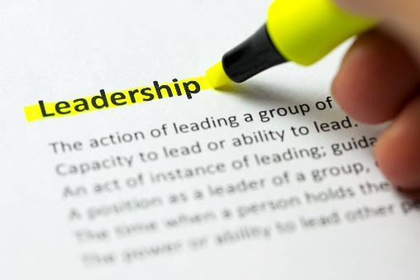
Leading in Uncertain Times—A four-part presentation focused on building skills for crisis decision-making and managing culture during disruption.
- Lessons Learned During the 2008 Recession, Abe Eshkenzi, CEO, American Production and Inventory Control Society (APICS).
- Scenario Planning, Sharon Rice, Managing Director Business Strategy, .orgSource
- Lean on Your Culture in Difficult Times, Kevin Martlage, Senior Consultant, .orgSource
- Where do We Go From Here, Sherry Budziak, Founder and CEO, .orgSource and Kevin Ordonez, Managing Director, Technology, .orgSource

Watch Here

Upcoming .orgCommunity Webinars

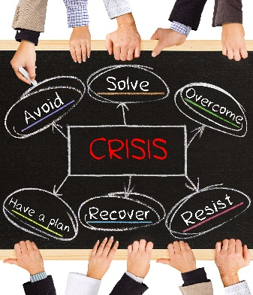
Use Impact Mapping to Thrive in a Crisis, March 24, 11:30 a.m. Central, Greg Larkin, best selling author and entrepreneur will explain how to find opportunity in crisis using impact mapping. Since 2005, Greg has been transforming huge companies with new, innovative products. His innovation journey began when he published the earliest prediction of the financial crisis of 2008. Since then he’s launched over thirty breakthrough products at companies like Google, PwC, Nestle, Bloomberg and Allianz.

Reserve Your Seat


Moving from Bricks and Mortar to a Virtual Office Quickly, March 26, 2020, 11:30 a.m. Central, Sherry Budziak, CEO and Founder .orgSource and Travis Cheatham, Director of Technology Operations and Digital Solutions, American Association of Clinical Endocrinologists (AACE). Budziak and Cheatham will discuss lessons learned during AACE’s transition to becoming a virtual company. Hear how the roll-out to 100 percent virtual business was expedited as a result of COVID-19.

Reserve Your Seat

READ

Sherry’s Budziak’s Blog

Turn Panic Into Purpose—Lead Through COVID-19 With Confidence
Read More


Remote Doesn’t Mean Removed—Lead a Successful Virtual Team
Read More

Sherry Budziak and Kevin Ordonez’s Books

A crisis asks us to turn the resources we have into something greater than we imagined they could be. Creativity and innovation are invaluable skills. Read how entrepreneurs and CEOs in the association use disruption to find opportunity,

Association 4.0: Positioning for Success in an Era of Disruption

Association 4.0: An Entrepreneurial Approach to Risk, Courage and Tranformation

BROWSE

Keep an eye on the .orgSource COVID-19 resource page for regularly updated information.

