My Perspective

Business as Usual has Left the Building
“What’s dangerous is not to evolve.” Jeff Bezos



Dear Fname:
Spending hours (a lot of hours) with the people we are closest to and zero time with everyone else is one of a thousand things that seem out of balance in our new reality.

Sherry Budziak
It isn’t easy to stifle fear and stoke the resilience, hope, and creativity needed to be strong until we see the end of this challenge, but I have faith in the association community. Our leadership and our organizations are more important than ever. I know that all of you are focused on giving your best professionally and personally to the staff, volunteers, and members who depend on you for guidance.

I’ve been writing and speaking about the need to prepare for disruption for several years. I thought that technology would probably be the source for the most sweeping changes to our industry. It turns out I’m wrong—at least for today. COVID-19 is a lesson in what we already know but, most of the time, choose to forget. There is no normal. The world changes on a dime in ways that are always surprising and often completely unexpected.

It’s impossible to prepare for every unpredictable event. But with innovation, mental agility, and foresight you can survive, and even succeed, a disaster. The Association 4.0 books (Positioning for Success in an Era of Disruption and An Entrepreneurial Approach to Risk, Courage, and Transformation) that I wrote along with Kevin Ordonez were motivated by our interest in exploring how these qualities are being cultivated in the association community and what we could learn from people who strive to build the kind of adaptive cultures that thrive on change.

We interviewed 47 CEOs and entrepreneurs who are compulsive innovators, problem-solvers, and builders. These are some examples of how our contributors prepared for obstacles and found opportunity in disruption.

Excerpts from: Association 4.0: An Entrepreneurial Approach to Risk, Courage and Transformation

Seize Opportunity

Kevin Hostutler, President, CEO and Co-Founder, ACGI Software (Chapter 9)
“On Friday the 13th of September 1996, a day I’ll never forget, my co-workers and I were called into a conference room and handed pink slips. My wife was expecting our third child in three years. . . The hardest thing I had to do was go home and tell her that I had no practical means to support our family.

“The next week my customers started calling. My business partner, Dan Kasprow, and I had been working on some large project implementations. Those clients hadn’t gone live yet, and they needed our help.
Kevin Hostutler

“One customer had a partially built membership renewal customization. All the organization’s cash flow was riding on bringing in those dollars by the end of the year. . . That association was just one of many organizations who had been abandoned by the company and were begging us for help. . . It took Dan and me eight business days to incorporate. A week later we were open for business. Dan was a bachelor, and we were working at his dining room table. Needless to say, that didn’t last long. With our first check we bought two laptops, and we rented an office. . .Twenty-three years later ACGI software is thriving and many of the customers who needed us back then are still with us today.”

Have a Vision

Roy Chomko, CEO, Adage Technologies, (Chapter 18}
Roy Chomko
It was 1999 and signs of recession were already surfacing. Then came the dot.com stock market crash in March of 2000, followed by the attack on the World Trade Center in September 2001.

Chomko and his partners had to decide how to position their company in a precarious economic and social environment. The group was divided on strategy, and Chomko and another like-minded partner split to start Adage. “We didn’t feel that the other folks were looking at the reality that 2001 was bringing”. . . We had a purchase order that was intended to keep us going for half a year. Just one month into the contract, the client called and said, ‘Rip up the purchase order and bill us for what we owe.’ Their stock had hit bottom, and the employees were all taking early retirement.”

Adage stayed afloat but continued to experience growing pains. . .“There were times, even during the first 10 years, when I thought if I had stayed in technology sales, I could have been making more money and working less,” says Chomko. “But . . . I believe that you need persistence and patience to keep on working toward your goal, even when success seems elusive. Making money, for me, is secondary to wanting to innovate and create.”

Excerpts from: Association 4.0: Positioning for Success in an Era of Disruption


Think Boldly
Dawn Sweeney
Dawn Sweeney, former CEO, National Restaurant Association (Chapter 14)
. . . in 2008, after 19 years of consecutive growth, the Great Recession hit the United States economy hard. Sweeney. . . understood that opportunity lay in helping the industry weather the storm. . .

Although membership grew during the recession as restaurant owners were searching for coping strategies, dues were not the answer to helping members or the association through the economic downturn. Sweeney understood that Instead of retracting during the recession, she had to be proactive and fill industry needs. Programs and services had to grow. Building on a firm base of existing initiatives, the association launched a health insurance offering customized to the restaurant industry, expanded its food safety programs, supported advanced credit card processing, grew the trade show, and engaged more actively in advocacy. The industry and the association emerged from the recession stronger than ever and have continued to grow. NRA increased its annual revenue from $50 million in 2007 to $116 million in 2016.


Be Adaptable
Peggy Winton
Peggy Winton, CEO and President, Association for Intelligent Information Management (Chapter 2)
“Digital transformation has so many meanings. . .People are viewing technology and its relationship to their work in totally different ways. Change and new business models are occurring in unexpected places,” says Winton.

AIIM had to consider whether its core services would become irrelevant. Leaders took a hard look at the technology landscape and their industry’s competencies. . .That journey led them to the decision that content is, and will continue to be, a significant component of digital transformation. However, the board and staff also realized that this was the optimal time to define their purpose in more holistic terms and to move toward an analytic, data-centric, and application-oriented approach.

AIIM used information-driven terminology to develop a road map for digital transformation. The process, which they call intelligent information management, provides a foundation to support additional layers of resources and technology. AIIM now has a set of tasks and strategies that will integrate successfully with emerging trends.

Our contributor’s stories illustrate the resilient, innovative approach needed to succeed in an environment characterized by rapid economic and social change. It’s a state of mind that recognizes opportunity, is inspired by vision, plans boldly and adapts with ease. These qualities are far more important than any technology, but they are also the characteristics that motivate people to use the powerful tools at hand with invention and creativity.

Stay safe and healthy,

Sherry

A Trifecta of Strategies for Smart Decisions

When it’s time to make a difficult decision do you?

- Consult the I Ching
- Ask your dog for advice
- Cross your fingers and hope for the best

Without an objective process for decision-making, finding the right solution can seem as arbitrary as any of the options above. Following are three strategies you can use to put complex problems into a manageable framework.
Without an objective decision-making process, finding the right solution can be as arbitrary as asking your dog for advice.

Each of these methods explores issues through a different lens. One might be more suitable than another for the question you and your organization are trying to answer. To access an in-depth discussion about each process along with illustrations, click on the link to .orgCommunity’s recent webinars.

Envision the Future
Scenario planning examines several possible futures and prepares the organization to be proactive and agile in responding to changing conditions. Scenario planning can be used for both long and short-term decision making and can address complex problems or be streamlined to provide for more immediate solutions. Sharon Rice, .orgSource consultant and expert in all things strategic, described some of the benefits like this, “Scenario planning fills you with information and an understanding of the possibilities. Exploring options can give you some control over a chaotic situation or a path forward in an uncertain future.” To learn more click here.

Project the Outcomes
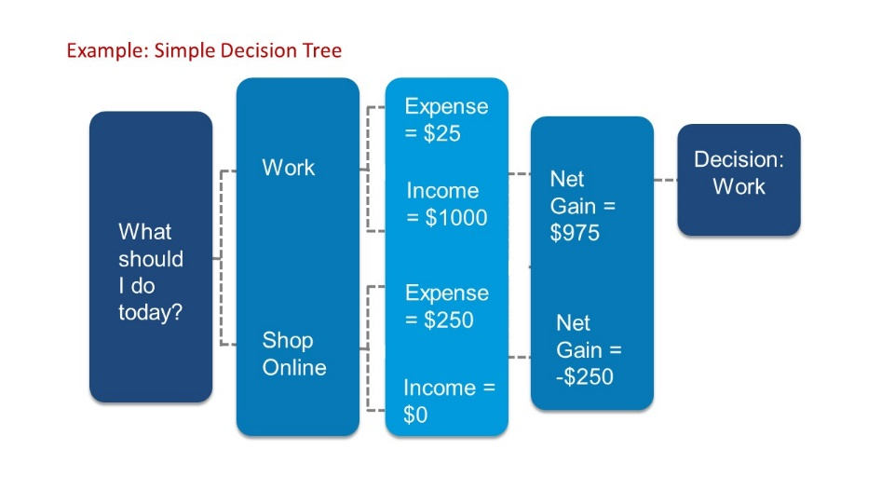
Decision trees are a tool that the business world co-opted from computer programmers. They are a graphic framework that uses estimates and probabilities to project the likely outcomes and net gains of various alternatives. Decision trees are built from tables or matrixes that are illustrated in a branch format. They are easy to create but it bears remembering that they are also only as good as the estimates used in the calculations. “A key thing about decision trees is,” says Rice, “there have to be alternatives. You must be seeking to evaluate several options.” To learn more click here.

Maximize the Impact
Impact mapping can be used to identify the resources, outcomes, and deliverables that are needed to reach a critical goal. This process is effective for navigating a crisis situation or for achieving more long-term objectives. “But,” says Greg Larkin, bestselling author and entrepreneur, “if you’re working in a crisis make sure you’re focused on a wartime goal.” A peacetime goal might be: How can we increase our annual dues revenue by 15 percent? A wartime goal is: After this crisis, we can become more resilient by ______. We can start now by _______.

The four pillars of an impact map are a goal, people, impacts, and deliverables,” says Larkin. “It’s a super simple tool.” Impact maps provide a visual representation of the interrelationships of people, outcomes and achievements. To learn more click here.

Each of these tools offers a visual medium for presenting challenges, solutions, and a rationale for action. Use them to help your team manage risk, identify options, and promote buy-in.


Empathy—A Powerful Path to Growth
Building trust facilitates growth and change.
A crisis puts the focus on leadership skills, but the qualities that help professionals manage through tough times are the same characteristics that enable organizations to succeed in the evolving digital business environment. Building trust is one of the most effective strategies leaders can use to facilitate growth and change.

A history of accomplishments and wise decisions puts you partway toward that goal. But if your team doesn’t believe in your commitment to the organization and to their well-being, it will be difficult to convince them to follow you into risky territory. Empathy establishes the human connection that allows others to see you as trustworthy. Empathetic leaders:

Get off the Island
Don’t isolate yourself from your team. Whether you are working virtually or in person, make time to directly connect with as many people as you can. Listen to their ideas and recognize their contributions in meaningful ways. Don’t ignore problems, work to find solutions. The person at the top provides the positive attitude and reinforcement needed to keep everyone on track despite challenges.

Forget the Golden Rule
Treating a colleague the way you would like to be treated yourself won’t be effective. We all see the world through different eyes. Being empathetic means that you become the “other”—you can hear someone else’s soundtrack. By asking probing questions, you’ll uncover real concerns and, better still, receive honest feedback and advice.

Tame the Tiger
Don’t encourage “happy talk.” Ask people about their concerns. Address issues head-on. Do not evade or redirect that will create anger and resentment. Listen and do your best to understand.

Take Responsibility
Don’t be afraid to apologize or admit mistakes. Assuming responsibility or sharing someone else’s pain is the highest form of empathy.

Empathy will reward you by turning employees, who were a team in name only, into colleagues who are collaborators and partners in taking the organization where it needs to go, even when the journey isn’t easy.

Read Sherry Budziak’s Latest Blog Posts


An Integrated Digital Strategy Is a Lifeboat in Turbulent Water

In a crisis, like the current pandemic, an integrated digital strategy can make the difference between business as usual and a meltdown. Travis Cheatham, Director of Technology Operations and Digital Solutions at the American Association of Clinical Endocrinologists, has firsthand understanding of how the right approach to technology can impact an organization’s ability to navigate tough times. If COVID-19 has brought your association’s technology deficit out of hiding, Travis’s perspective on AACE’s digital transformation will be both helpful and hopeful. Read More


Virtual Meetings Grow Association Communities—How to Get Started

Canceling a conference is a decision that most association CEOs never imagined they would be forced to make. But many organizations recently faced that challenge, and more will probably do so in the near future.

Fortunately, technology now gives us alternate ways to continue our work, including providing members with education and fellowship. Virtual conferences and meetings are more than an option. They are an increasingly popular way of convening that organizations should embrace for reasons that go well beyond the current challenge. Read More

