The Delicate Balance

A Critical Conversation About Trust, Value, and Belonging
The .orgCommunity Leadership ColLAB

Contact:
Sherry Budziak, CEO and Founder, .orgSource, Co-Founder.orgCommunity
2033 Milwaukee Ave.
Riverwoods, IL 60015
847/275-1840
Sherry@orgcommunity.com
www.orgcommunity.com
Contents
May 2023

Introduction 3
The Leadership ColLAB 3
The World Café Format 4

Diminishing Trust 5

Declining Motivation To Belong 6

Searching for Value 7

Struggling To Find Community 8

Aligning Mission 10

Elevating Trust 11

Meet .orgCompanies 13

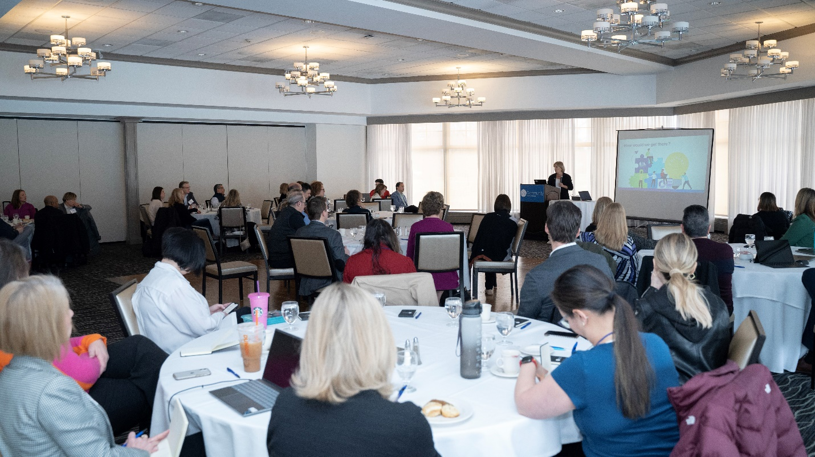
Introduction
The .orgCommunity Leadership ColLAB
Even compulsive digital trend watchers are astonished by the tsunami-like rise of AI. Predicted outcomes range from inspiring and fantastic to dire. The profound uncertainty about actual consequences makes AI an excellent example of technology’s destabilizing impact on human behavior.

At .orgCommunity, we are students of the qualities that associations need to navigate disruptive business environments. Leadership skills like curiosity, collaboration, and adaptability are traits we promote in our consulting practice. Two books we wrote on this topic outline our approach to positioning organizations for success in the digital era.

Recently, a more foundational, yet less recognized, phenomenon captured our attention. It’s a concept that we were eager to explore with our community.

Membership in religious organizations, voluntary groups, and yes, associations is waning. The idea that lack of trust is fraying ties that were once essential social connections is gaining traction.

The Leadership ColLAB
Trust isn’t a challenge that is currently top of mind for association professionals. But at .orgCommunity we like to consider issues before they become sound bites. The Leadership ColLAB conference was an opportunity to bring colleagues together to discuss this topic.
In the era of remote work, collaboration and dialogue are indispensable to professional success. Through our conferences and Peer-to-Peer Circles, .orgCommunity is committed to creating time and space for professionals to exchange ideas and learn from each other.

The ColLAB, which was exclusively for .orgCommunity’s VIP members, took place on March 2, 2023 at the Rolling Green Country Club in Arlington Heights. Sharon Rice, .orgSource Managing Director of Business Strategy, facilitated the conversation. Sharon is a futurist and avid consumer of the latest research, data, and provocative insights from industry thought leaders. She has been following the dialogue around trust for some time.
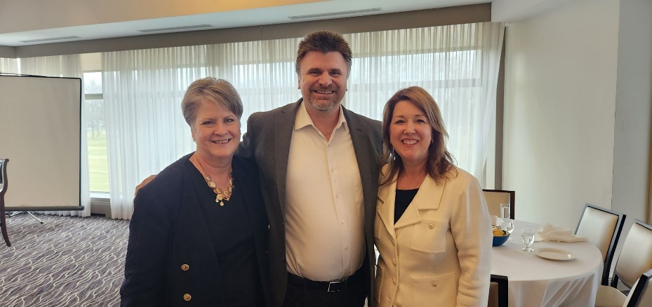
Sharon Rice, Managing Director Business Strategy, .orgSource chats with Sherry Budziak, .orgCommunity Co-Founder and Brian Willard, Director of Information Technology, CCIM Institute
Nancy MacRae, CEO at the Emergency Nurses Association and Kristine Hillmer, CAE, President and CEO of the Wisconsin Restaurant Association bookended the group conversation. Their presentations described how trust and culture were pillars of support for their organizations during the pandemic.

The World Café Format
To maximize the brain power of our .orgCommunity professionals and to allow for a robust exchange of ideas, Sharon utilized the World Café format as a framework for the dialogue.

The World Café is a strategy designed to deeply explore a series of topical questions. Participants were divided into approximately seven tables of eight to 10 people. Groups discussed the same question simultaneously. Then switched tables to address the next topic. Three issues, which move from broad to specific, were considered.
- Do our members and stakeholders view our association as legitimate?
- Could the decline in membership be a reflection of the decline in trust?
- How can we restore trust in our work, our organizations, and our leaders?
This article summarizes the conversation. We’ll also explore current considerations about trust and the complex relationship between trust, belonging, and value.

Diminishing Trust
Trust is the glue of life. It’s the most essential ingredient in effective communication. It’s the foundational principle that holds all relationships. - Stephen Covey, author and leadership expert
The glue that Covey references is deteriorating. We are experiencing one of the most polarizing eras in American history. If you track current events, you are aware of the erosion of public confidence across a spectrum of industries. The police, healthcare organizations, religious groups, financial institutions, and news outlets are all subject to greater scrutiny and skepticism. Even the Supreme Court is under fire.
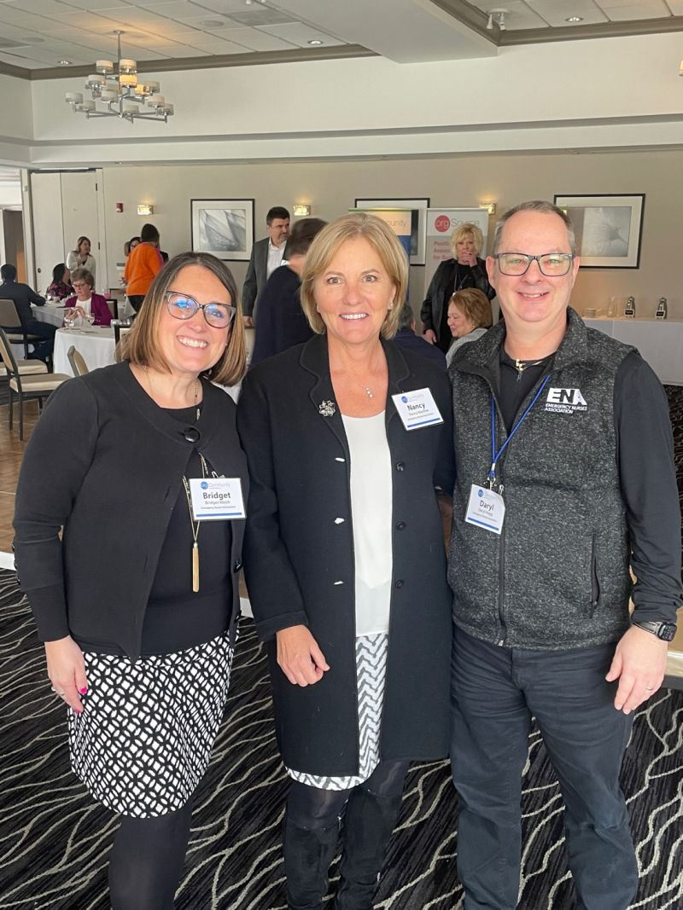
Lowered esteem for organizations, whose solid reputations were previously taken for granted, is not anecdotal. The Pew Research Foundation, which has been tracking trust in government since the 1950s, reports that public confidence has been waning for decades. In 1958, 73% of Americans said they trusted the government to do what is right "just about always" or "most of the time." By 2022, that number had fallen to just 20%.
Nancy MacRae flanked by ENA staffers Bridget Walsh, COO (left) and Daryl Hogg, Sr. Director, Information Technology (right)

Rice noted that 50-year longitudinal studies from Gallop Poll, NORC’s General Social Survey, Harris Poll, and Edelman Barometer, identify the same declines in the credibility of public institutions and their leaders.
Edelman points to four forces that are influencing trust:
- Economic Performance and Expectations of Future Income. People across the developed world are not confident that their families will be better off in five years.
- Institutional Imbalance. Business is the sole institution seen as competent and ethical.
- Mass-Class Divide. Those in the top quartile of income have a profoundly more positive view of institutions than those in the bottom quartile.
- The Battle for Truth. As divided views become entrenched, no institution is trusted; only 26 percent of people with a polarized mindset trust government, and only 35 percent trust media, leading to a cycle of dysfunction.
The fact that business still retains credibility is positive. However, a 2021 Independent Sector survey found that only 56% of Americans trust nonprofit organizations, which is cause for concern, especially for associations.
Adding to the disruptive impact, multiple traumatic social and cultural events characterize the formative working years for younger generations. Experiences like the following make Millennials and Gens X and Z, groups that associations are seeking to engage, consider even long-standing organizations with a dose of suspicion.
- September 11th
- The 2008 mortgage crisis
- The Great Recession
- The 2016 Election
- The COVID pandemic
- The murders of George Floyd, Breonna Taylor, and Tyre Nichols
- January 6
- The current inflationary economy
Declining Motivation to Belong
"The feeling of belonging is a powerful motivator." - Simon Sinek, author and motivational speaker

Current declines in organizational membership parallel the declines in trust. Gallup reports that in 2020, the number of people belonging to a religious organization dropped below 50 percent for the first time in eight decades.

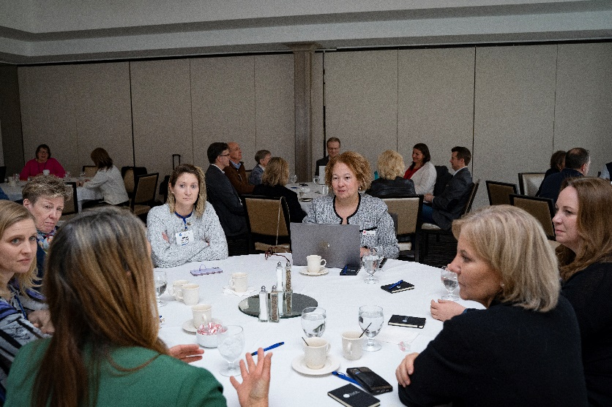
Rice offered an example closer to home. In the early 1950s, about 75% of physicians were AMA members. By 1984 less than 40% of US doctors belonged, and by 2016 that number had dropped to 20%.
ColLAB participants rotated among tables and facilitators as they considered the three questions.

“The Belonging Barometer, The State of Belonging in America,” a recently released study from the Immigration Council finds that the majority of Americans report a sense of non-belonging.

Rice notes that, “despite increased participation in social media, or perhaps because of it, Americans feel less connected. Seventy-four percent don’t feel they belong to their communities. Sixty-eight percent don’t feel they belong in the nation and 64% don’t feel they belong in their workplace. Two out of three employees in the US feel isolated at work. That sense of separation has an impact on the willingness to join.”

The Immigration Council advises that the purpose of their research is to alert leaders to the importance of this issue. “We make the case for including belonging in the design and implementation of programs and policies across all areas of life in the United States.”

Searching for Value
"Members join organizations for a reason. They want to get something out of it." - Mark Cuban, entrepreneur and billionaire

As the group moved through the three questions, much of the conversation centered around changes in the relationship between belonging and value.

Belonging is at the core of every association’s mission. Based on the dialogue, and our consulting experience, declining membership is clearly a concern for some groups. Whether future workers will be motivated to join a professional organization is an open question.

Leaders are asking if associations, can or should, reinvent business models to accommodate a new generation of professionals whose needs and expectations for belonging are both uncertain and changing.

Participants agreed that the desire to trust is foundational and an overarching influence on membership.

“Having to take over as a young leader for a beloved department head who passed away, the best advice I got was that I needed to build trust in order for the others to follow me. There’s no leader without followers.”

“Trust takes so long to build and so little time to break and it’s hard to build up again. The Detractors are vocal and have a bigger forum now. Communication and telling your story becomes critical.”

ColLAB Commentary

However, trust did not emerge as the bleeding issue, at least among this group. The majority appeared to believe that their members have confidence in the organization’s integrity.

On the other hand, value and the ability to deliver on individual member demands were repeatedly referenced as the current drivers for belonging.

“Throughout a large portion of my career,” Rice observed, “many professionals belonged to their association out of a feeling of responsibility. They wore membership like a badge of quality. There was an emotional attachment to associations as community.

“Today the more subjective aspects of membership are waning, and the decision to join is becoming a value judgment. Members are asking—'Did I participate enough for my investment.’ It feels like a hamster wheel. The staff strives to keep delivering new products and services, and the return on those initiatives seems to be diminishing.”
ColLAB Commentary

“I can’t say I’ve seen a lack of engagement due to a lack of trust. It’s difficult to give tangible value for things like certification. Younger generations are seeking out specific activities, but they are less interested in membership. The value proposition has changed. It’s no longer about being part of a tribe. Now it’s more of a Costco (membership for value) thing.”

“For us, it’s not trust, it came down to finances. During COVID, our organization felt the stress level of the traditional association model. We provide membership conferences, but we need transformation in our business model. Professional development dollars were cut. But leadership still wants us to offer anything and everything to everybody. There is a fear of change. We can’t make assumptions that what worked before will still work.”

“My engagement is always about what’s in it for me or value. I find it’s more transactional. You trust that what you’re paying for you’ll get back.”

“We must create value and then build trust around that. People ask, ‘What is in it for me?’ It is no longer true that if you build it they will come. You have to show value first and build trust from there.”

Struggling to Find Community
"The best membership communities are those that are built on trust, respect, and collaboration. They are places where members feel safe to share their ideas and where they can get help and support from others." - Brian Tracy, author and motivational speaker

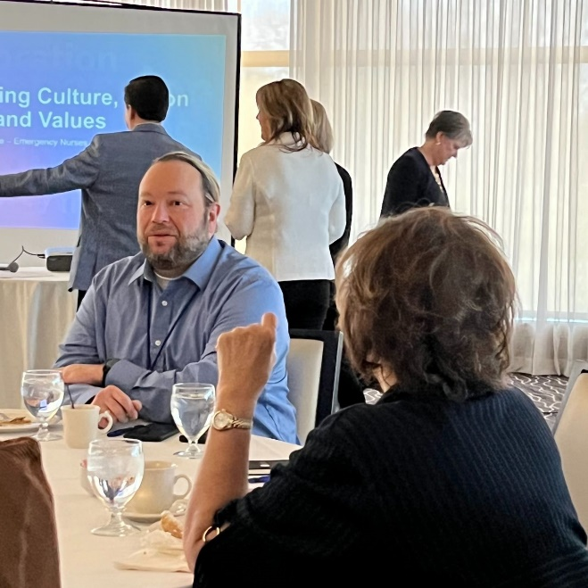
For associations, belonging has always been the X factor, the special ingredient. No other provider of professional development could replicate the camaraderie found in a group of peers. The ColLAB identified forces like the following as responsible for weakening these relationships and the traditional feelings around networking and community.

- Industry consolidation, subspecialties
- Competition from member influencers
- Competition from other providers
- Work/life balance issues
- Different expectations from a younger generation
- Decreasing numbers of young people entering some professions
- Leadership’s fear of change
ColLAB participants discussed networking and community.
- Noise from social media

It’s not unreasonable to think that value is rising in importance as a result of the struggle to redefine belonging. Association leaders are searching to create a sense of community that overrides or accommodates these issues, but they are uncertain about how to accomplish that goal.
ColLAB Commentary

“People want to be part of a community but they’re not sure how to equate that with their profession. We can define ourselves in so many ways now. How can we blend different professional aspects for a more holistic experience? And do
people want to belong? Can we create communities within communities? Everyone wants to figure out what’s right for them.”

Association professionals are acutely aware that relationships are a significant component of their value proposition. As culture, technology, and business continue to impact preferences, there is an urgency to find new paradigms for belonging.

This dilemma is not dissimilar to the adjustments organizations are making to remote work and the need to cultivate community in a changing environment. It’s easy to understand how the focus on engagement has shifted away from trying to reinvent complex human dynamics to improving more tangible benefits like products and services.

Aligning Mission
"A mission that is aligned with the values of its members can help an association build a strong culture." - Jeff Goins, writer, speaker, and entrepreneur
“You can get people to feel that community again, just on a smaller scale. They want quick things they can join and gain a sense of belonging and then opt out of. The consumer mindset has changed. Membership has to be packaged differently. Unique customized experiences seem to be attractive.”

“If the model is broken, how can we adapt to the various needs? Think of Netflix and how they personalize experiences. We are hearing that members want customized interactions (which may be another word for their perceived value).

“We need to let members consume the content, the way they want to. We have to cover all the bases—audio, print, video, or people will leave.

ColLAB commentary

Despite the shift toward value as a commodity, associations are not corporations. They don’t exist to make a profit or enrich shareholders. Although their purpose includes member satisfaction, their reason for being extends beyond individual gratification. Associations have the overarching responsibility to uphold professional integrity—to be a public face.

This significant obligation is founded on trust. It is a strong argument for taking a proactive approach to cementing the bond between trust, value, and belonging.

The presentation that Nancy MacRae and Kristine Hillmer gave underscored the important role a culture of trust played in keeping their organizations and their members’ heads above water during incredible pandemic disruption.

Nursing and hospitality were among the industries most severely impacted by COVID-19. MacRae and Hillmer’s experiences highlight the benefits that a focus on credibility brings to every relationship and the most stressful situations. Hillmer shared this story.
“I’ve always understood the importance of relationships. But COVID reinforced that lesson. Pre-COVID, we had a program called the Milwaukee Kitchen Cabinet. The goals were to talk about the great things that restaurants do in their communities. And, through those stories, to develop relationships with the media and elected officials in that market. We leveraged our connections during COVID by organizing a weekly call to convene the key players. When the Public Health Department was looking at how to reopen safely, they had a sounding board and we were able to collaborate to develop successful solutions.
“On the other hand, in Madison, where we didn’t have a Kitchen Cabinet, collaboration on reopening was much more challenging. There was no working partnership with industry and public health. That hammered home the connection between relationship building and trust.
A common thread in both presentations was the balanced approach to members and mission. These organizations are delivering value by meeting individual content, information, and educational needs while giving equal attention to the mission by consistently strengthening its public integrity and stoking a passion for professional excellence throughout the membership. That equilibrium is the foundation for building the strong and trusting cultures that promote belonging.

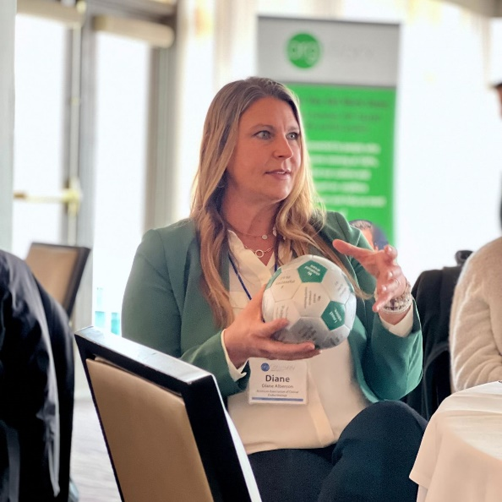
Elevating Trust
Association professionals acknowledged the importance of transparency and effective communication.
"Trust is the foundation of all great companies. It's what allows us to work together, innovate, and achieve great things." - Satya Nadella, CEO of Microsoft

The examples from ENA and WRA suggest that keeping eyes firmly trained on the mission may be the key to delivering value while growing trust and building community.

ColLAB participants universally acknowledged the importance of fostering qualities such as transparency, follow-through, dependability, and effective communication, that promote trust and a positive culture.

ColLAB Commentary
- The association has to deliver positive experiences over time – consistency is key.
- Actions and behaviors must align with messaging.
- Promoting diversity, equity, and inclusion is critical.
- Staff training is key to creating a trusting environment.
- Lack of transparency destroys trust – However, there is a difference between being transparent and communicating everything.
- Storytelling is important.
- Accountability is key.
For leaders who want to make trust an organizational priority, Rice recommends Stephen Covey’s book, “The Speed of Trust,” as a resource. The book is a good place to begin exploring where your association falls on the trust continuum.
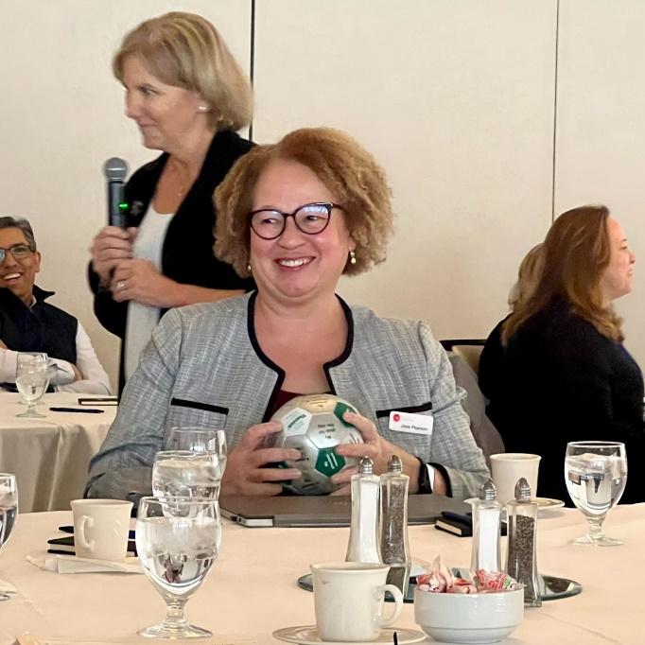
Rice explained, “Several years ago when I was helping a client to improve working relationships among board members, I came across Covey’s book. I was impressed with the way he takes trust outside the realm of culture and psychology and puts it into the world of commerce. He gives an elusive quality concrete parameters and demonstrates its significant impact on operations. Then, he offers a framework and strategies to begin developing trust on multiple levels.”
“I was attracted by the fact that Covey makes trust learnable, and he takes it beyond one-to-one relationships,” Rice advises. “He identifies these five dimensions where trust needs to be established.”
- Individuals need to trust themselves.
- The team needs to trust each other.
- Committees and other groups need to trust the organization.
Jane Pearson, .orgSource, Vice President of Marketing and Communication services facilitates a conversation.
- The organization and its members must trust one another.
- And finally, the company must be trustfully aligned with society.
Few associations can claim success across all five dimensions. But it is certainly a goal to aspire to.

Building trust, like many other things in business, is a journey that begins in an obvious place. Covey advises that before anyone else can trust you, you must evaluate yourself against these four measures of trustworthiness.

Integrity
Integrity involves being true to yourself and others. When you set goals, do you follow through? If you tell your staff that their well-being is a top priority, do you keep that commitment when the board suggests cutting back on health insurance benefits to balance the budget?

Intent
Intent refers to the motivations behind our actions. Intent and integrity should be in alignment. How you behave should be driven by your values. In the workplace, especially, intentions should center on what is good for the group as opposed to what is best for you. Hidden agendas, favoritism, and quid pro quo are examples of intentions that erode trust. Integrity and intention are related to character or mental and moral qualities.

Competency and Results
Competency and results have to do with how you and others evaluate your ability to deliver on expectations. Do you have the right skills for the job, and can others count on you to produce the anticipated outcome? Are you honest about your abilities, and do you delegate tasks you’re not equipped to perform successfully?

Once you’ve evaluated your own weaknesses and strengths, then you can begin helping your organization to build skills across the four dimensions.
Participants didn’t come to the ColLAB viewing trust as a primary leadership issue. It’s not a topic that appears on meeting agendas or even in private conversations often. Where trust is limited people are reluctant to consider the deficiency and where it’s strong, there is little need for discussion.
The ColLAB put this issue front and center. It allowed everyone to reflect on the status of confidence in their organizations. The conversation also heightened awareness of the need to build trust to provide value and belonging. Maintaining the delicate balance between these three qualities and giving each its due attention is the challenge of leadership in the digital era.
As AI and other technologies extend our lives further into virtual realms and reality grows easier to manipulate, trust will undoubtedly become a more common and a more complex topic. Beginning that dialogue early allows associations to practice Covey’s four qualities and grow their unique strengths and responsibilities in the business community.
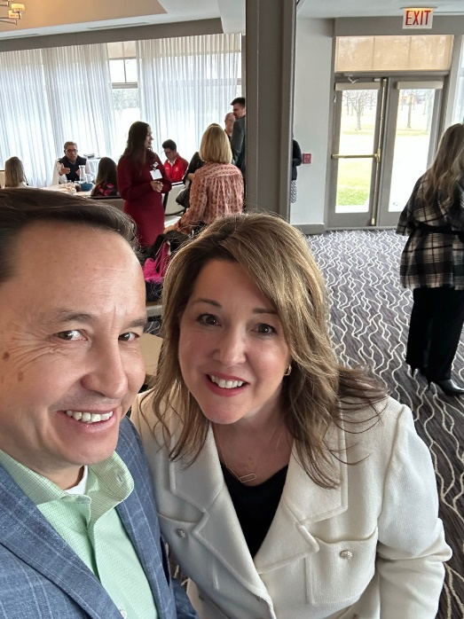
Meet .orgCompanies
.orgCommunity Co-Founders, Sherry Budziak and Kevin Ordonez
.orgCompanies is dedicated to supporting associations as they undertake transformational change. We offer strategic guidance, practical solutions, and access to a vibrant network of executives and education to strengthen associations and the value they provide. Three related organizations form the .orgCompanies brand:

.orgSource provides association leadership teams with strategies and data-driven solutions that reflect our deep understanding of the challenges that associations face and our knowledge about approaches to overcoming them. Our success spans fifteen years and represents more than 200 client engagements. From developing an integrated strategic plan to preparing your association for a digital future and supporting the implementation of your important projects and initiatives, .orgSource’s experienced advisors are ready to serve your needs. .orgSource
.orgCommunity connects members to a vibrant network of executives, entrepreneurs, and strategic partners dedicated to shaping the future of associations. Members have access to collaborative events, small group learning opportunities, and peer-to-peer counsel with trusted allies, mentors, and friends who share a passion for excellence. .orgCommunity

.orgWorx quickly connects organizations with vetted talent to help build diversity and capacity. With a deep understanding of the nonprofit sector and access to the resources from our .orgSource brand of companies, we match association experts with employment vacancies including: interim staffing and consultancy positions, temporary leadership gaps, transitional staffing, interim management/senior level positions, special projects, and, through our new recruitment service, standard association career positions. .orgWorx

Discover our philosophy of Association 4.0 leadership in our books: Positioning for Success in an Era of Disruption and An Entrepreneurial Approach to Risk, Courage, and Transformation. Let us share .orgCompanies’ passion for designing premium solutions for associations with you.

