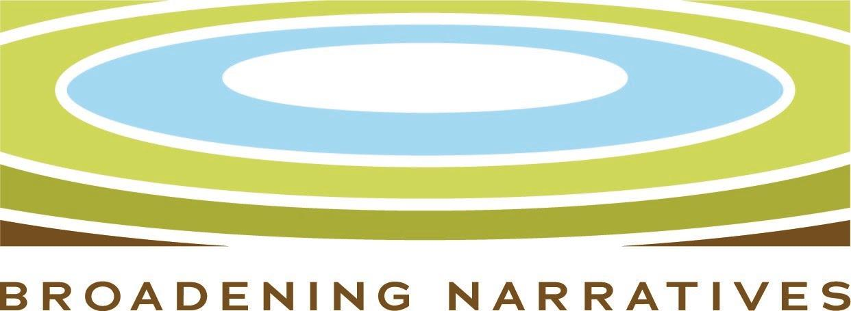
Broadening Narratives Application 2021
Welcome to the Broadening Narratives Application 2021.
Collections are comprised of diverse narratives that provide perspectives from the past, contribute to a better informed present, and lead to a more inclusive, sustainable and healthier future. We encourage collecting organizations in our two regions to amplify overlooked voices and animate and expand the stories and insights derived from their collections. Diverse narratives include the stories and perspectives of culturally specific communities—African Americans, Indigenous peoples, and other people of color—LGBTQ perspectives, working-class narratives, small community experiences, as well as other underrepresented groups and viewpoints. Emerging, compelling underrepresented perspectives reflective of collections in the areas of science, public health, and the natural world are also important to our regions’ collective narratives.

Organization Info
Organization Legal Name Chicago Public Art Group
If you are a fiscally sponsored group, what is the name of the organization that is serving as your fiscal sponsor?
An MOU between the fiscal sponsor and the sponsored organization must be in place for an application to be considered.
Organization Mailing Address 3314 S. Morgan St., Unit 1, Chicago, IL 60608
Primary Phone 312/427-2724
Website Chicago Public Art Group
What type of organization are you? Public Art, Culture, and History
If Other, how do you identify? Have a collection, but your primary mission is not collections, e.g. culturally specific, religious, etc.
Secretary of State confirmation - A screenshot is acceptable. Must be valid/unexpired at the time of your application.
Year Founded 1971
Brief Description of the Organization
The Chicago Public Art Group’s (CPAG) mission is to unite artists and communities to create public art. Our goal is to expand the tradition of giving voice to communities through art that represents their history, aspirations, and challenges. In the wake of current social and political unrest, this vision has never been more relevant.

CPAG’s history begins in 1967 at the Wall of Respect. William Walker, and 14 other African American artists and activists, painted a mural on the side of a south Chicago grocery and liquor store.

Walker saw murals as a collective voice for the oppressed. His work was both an expression of their struggles and a call to action. The Wall of Respect recognized 50 African American heroes. Portraits, including Harriet Tubman, Aretha Franklin, and W.E.B. Du Bois, reflected the richness of Black culture and placed images of accomplishment and leadership where they would inspire daily life.

Motivated by an expanding revolutionary art movement, in 1972 Walker and John Weber formed the Chicago Mural Group, renamed the Chicago Public Art Group. Their goal was to forge partnerships between artists and communities and provoke social change. Together they would make walls that were once silent, speak with defiance, hope, and pride, and uplift people whose stories needed to be told.

Today, CPAG’s work dignifies public spaces and promotes citizen engagement throughout the city. The organization is grounded in these principles: Every Chicago resident deserves to experience great art; every community should have a voice; and public art and its creation encourage community investment and engagement.

CPAG has produced nearly 1,000 murals, sculptures, mosaics, playgrounds, and earthworks across the city. Neighborhoods as diverse as Roseland, Hyde Park, Bronzeville, Pilsen, China Town, and Pullman are represented in our portfolio. The installations run an aesthetic gamut from provocative to courageous and beautiful. Above all, they are emblematic of their place and time in the life of the city.

Primary Contact People
Primary Contact Person Chantal M. Healey, Executive Director
Primary Organization Contact - If different from Primary Contact above, please include Name, Title, Email, and at least one phone number.
Payee Contact - If a grant is approved, this person will be mailed the check or receive ACH
Chantal M. Healey
notification. If different from Primary Contact above, please include Name, Title, Email, and at least one phone number.

Financial Information
Financial Questions
What is your organization's fiscal year end date? •
December 31
Next fiscal year's budget, if available
- Current fiscal year budget for the organization with year-to-date profit & loss statement. Please make sure your fiscal year end date is included.
- Audit for most recently completed fiscal year o If you don't have an audit, please include a copy of your most recently filed 990 or 990EZ (Please do not send a 990-N).
  - If an audit or 990 is not available, please include an internally generated year-end profit & loss statement that includes your organization’s total net assets.
- Audit for two fiscal years prior
  - If you don't have an audit, please include a copy of your most recently filed 990 or 990EZ. (Please do not send a 990-N).
  - If an audit or 990 is not available, please include an internally generated year-end profit & loss statement that includes your organization’s total net assets.

Staff and Board Info
Number of Full-Time Staff Number of Part-Time Staff 2
Staff List - Include name, title, full-time/part-time status, and email addresses.
Board List - List of board officers and members. Please indicate the officers & include their contact information.

Proposal
What region is this collection by, for, and about? Chicago / Lowcountry
Chicago
This grant would support... Please provide a succinct project purpose/title here.
Cataloging, Promoting, and Utilizing CAPG’s Archival Collection for the Public Benefit
Total Project Budget - PLEASE NOTE: Project budgets are capped at $100,000. Capacity building project budgets must fall between $10,000 and $50,000. Upload Detailed Project Budget
$50,000
Grant Amount Requested Over how many months? 12
Briefly describe the project and how it will broaden the narrative.
- What under-represented community/culture/history does the project intend to highlight?
- What does this narrative add or change from what is currently in the public discourse?
- Is your organization by, for and about people who are BIPOC (Black, Indigenous, People of Color), LGBTQ+, disabled or primarily engaged with women-focused narratives?
"Our murals will continue to speak of the liberation struggles of black and Third World peoples; they will record history, speak of today, and project toward the future. They will speak of an end to war, racism, and repression, of love, of beauty, of life. We want to restore an image of full humanity to the people, to place art in its true context - into life." William Walker

Chicago is the birthplace of the community mural movement. William Walker and his fellow artists were its inspiration. Seven years after the Wall of Respect was painted, the city boasted 130 murals. Today, walls in every Chicago neighborhood are alive with color and images that inform, indict, inspire, and beautify.
CPAG is the guardian of this rich history of art, activism, and achievement. Our archives include 50 years of photographs, video, communications, records, artifacts, and memorabilia from the early days of the community mural movement up to the present. Much of this information documents the unwritten history of BIPOC and immigrant neighborhoods and people.
Many residents of Chicago are unaware of the wealth of art that surrounds them or its significance to the people and communities where it was created. Our archives can be a tool for educating people of all races, cultures, and age groups about public art’s unique role in society and how it impacts and expresses its surroundings.
This collective knowledge is more relevant than ever. The pandemic, the murder of George Floyd, and the Black Lives Matter movement have reignited the dialogue of activism and social justice in which public art began. CPAG can be a leader in these discussions, and our archival material can shed light on the past and provoke thought for the future.
We are collaborating with the Chicago History Museum to catalog the materials that we have and to determine how they will be used. These documents could form the basis for multiple initiatives from curricula to exhibits and even additional public art installations. Historians, students, teachers, researchers, and anyone with an interest in art or social justice are among the audiences who could benefit from access to this unique collection.
Does this project request funds for technology—digitization, online archival hosting, website upgrades, oral history archives, etc.? Upload technology plan.
Both hardware and software will be needed to organize our archives; however, at this point, we have not finalized a technology plan. We are working with the Chicago History Museum to identify our specific needs.
Is the proposed project outside your organization's primary area/s of focus? No
Is this a collaboration with another collecting institution? The Chicago History Museum
Describe how the collaborating partners will work together.
The Chicago History Museum is providing advice and guidance on the archival design, technology, and maintenance of the archives.
How do you propose to activate the collection to broaden public understanding about this subject?
These documents could form the basis for multiple initiatives from curricula to exhibits and even additional public art installations. Historians, students, teachers, researchers, and anyone with an interest in art or social justice are among the audiences who could benefit from access to this unique collection.
Where will the collection reside permanently? At the CPAG office and online
How will you evaluate the efficacy of the project? The project will be successful if CPAG’s archives are cataloged, and the contents are being used to provide educational, historic, and inspirational materials that can be enjoyed by people in Chicago and across the country.

Please provide 2-3 goals of the project and how each will be measured. If you’re requesting multi-year support, please include outcomes related only to the first year of work.
Goal 1 Identify the necessary technology and train staff to use the systems. Technology is identified and training has occurred.
Goal 2 Catalog the materials and documents. Materials are organized and ready to access for a variety of activities.
Goal 3 Develop a system for continuing to archive significant information. A system is developed.

