Become the Association Your Members Want
Use Strategy, Technology, Marketing, and Mission to get there

Contact:

Sherry Budziak, President

2033 Milwaukee Ave. Phone: 847.275.1840
Suite 324 Email: sherry@orgsource.com
Riverwoods, IL 60015 Web: www.orgsource.com

Contents
April 2021

An Opportunity for Action 2
Question the Past—Explore the Future
Begin with the Basics

Study New Trends 5
Understand Industry 4.0
Embrace New Generations
Integrate Technology, Strategy, and Culture
Use Data to Tame Disruption

Look Beyond Members 8
Lean Into Marketing
Seek Relevance

Build Community 11
Provide Purpose
Open Opportunities for Participation
Make Chapters Count

Mirror the New Dynamic 13

Introducing .orgCompanies 14

Seize the Opportunity for Action

We are about to press the reset button on the “Year of No.” President Biden has promised that by May 31, the vaccine will be available to every American. Meals with colleagues, brainstorming around the conference table, and maybe even shaking hands or giving hugs are not far off.

This moment, at the intersection of remote and in-person business and life, offers association leaders a unique opportunity for creativity, innovation, and bold action. It is a chance to evaluate how extreme disruption has impacted your organization and move beyond simply resetting to reinvention.

After 12 months of ongoing adjustments, why should associations continue a stretch, that for many, was uncomfortable? Consider this advice tough love: you crossed a burning bridge. You cannot return to the other side; however, you have the option to build it better.
This moment, at the intersection of remote and in-person business and life, offers unique opportunities.

Associations were the creations of their members and of the professions that gave those individuals a common purpose. Technology, demographics, economic, cultural, and social dynamics, that were in play long before 2020, are impacting that fundamental structure. The marketplace is shifting in ways that are unique in our professional lifetimes.

Question the Past—Explore the Future
Exploring current trends and integrating new thinking into governance and operations will position associations for success in an uncertain environment. But there is a need to go further. This point in time calls on leaders to abandon easy answers and tired templates, and evaluate their positions relative to the competition objectively. In a crowded field, to become the organization your members want, begin by asking these fundamental questions:

- Why does your association exist?
What do members value most about your work?
How does your organization positively influence the profession?
How well are you recognized among your constituents?
- If your association did not exist today, would industry leaders create it?
Are you providing unique benefits?
What circumstances are diminishing the value your association offers?
- In order to remain relevant, should your association’s mission change?
Are the dynamics of your professional community shifting?
- What will make your mission more compelling over the next decade?

Learn From Experience and Experimentation
.orgSource challenges clients to explore questions like the ones above. As an entrepreneurial organization, we are obsessed with seeing around corners. Discovering the vein of gold in what looks like an ordinary rock, identifying a sinkhole that threatens to swallow your investment, and putting leaders on track to navigate the future, is where we excel.

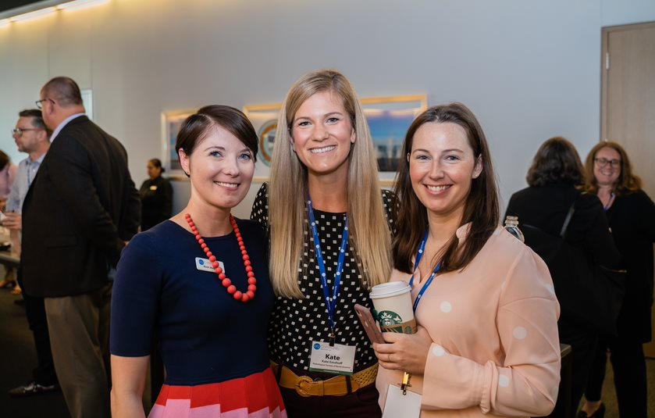
Our Association 4.0 books: Positioning for Success in an Era of Disruption and An Entrepreneurial Approach to Risk, Courage, and Transformation are a small part of the research we have conducted to help associations prepare for the unexpected. We interviewed CEOs across the country to discover how they are managing a volatile business environment. Their recommendations continue to influence our thinking and the advice we provide to our clients.

As the pandemic advanced, we were keenly aware of the apprehension and pain throughout our community. Clients and colleagues contacted us with questions about managing revenue shortfall, introducing new technology, and preparing for changing membership patterns.
When we seek input on critical issues, members of .orgCommunity are an invaluable resource.

When we seek input on critical issues, members of .orgCommunity, our networking and education organization, are an invaluable resource. We organized a Think Tank to help identify trends and crystalize our outlook on the future of membership. The sessions were facilitated by Elizabeth Engel, Chief Strategist, Spark Consulting. This article is the result of feedback gleaned during those dialogues, previous research, and the viewpoints of the .orgSource team.

Begin With the Basics
The wildfire spread of the pandemic was a real-time demonstration that we are emphatically citizens of the world. Where associations stand today is largely determined by how well they were already adapting to a global business environment.

Clearly, a robust technology infrastructure put organizations in a better position to manage this specific disruption. But even technology-rich groups coped with a myriad of unexpected challenges such as:

- How to compensate for sudden losses in revenue
- Whether to spend limited reserves
- When to cancel meetings and educational programs
- Whether to furlough staff
- How to address culture shock and volunteer burnout
- How best to reposition to gain market share

Experience with strategic decision-making is another reason some groups fared better than others. Adept change managers brought these entrepreneurial skills to the task. The ability to:

- Envision a successful future
- Use data to guide choices
- Employ tools such as scenario planning and decision trees
- Apply creativity and innovation to problem-solving
- Evaluate risk tolerance
- Take decisive action
- Identify missteps and pivot
- Be agile

Both these characteristics—a digital orientation to business and an entrepreneurial attitude to the marketplace—are prerequisites for successful membership initiatives.

Why is the starting point so basic? Shouldn’t we explore strategies for recruitment and engagement, tiered pricing, product development, or the right combination of in-person versus hybrid education?

The answers to those questions are important; but they are also different for every member group. On the other hand, whether an association is organized around manufacturing, the environment, or science and medicine, the path to correct decisions and the tools for implementing productive initiatives are the same.

Study Trends

There is one additional imperative for developing a successful membership program and sustaining a relevant organization. Associations must stop considering themselves a breed apart. They must look beyond tradition and their insular communities to assimilate and address the demands of the current business environment. The predominance of millennials in the workplace and the digital revolution are powerful forces driving new perceptions about membership.

Understand Industry 4.0
The pandemic may have changed our habits and slowed the economy, but it did nothing to stop the progress of the Fourth Industrial Revolution. The virus threw gasoline on a fire, accelerating a situation that was already precarious. Associations that were not prepared for digital commerce experienced a painful struggle to keep pace.
Industry 4.0 is characterized by the fusion of biology, technology, and the material world.

Industry 4.0 is characterized by the fusion of biology, technology, and the material world. It can seem more like science fiction than something that is happening in our current reality. The quick delivery of a vaccine to fight COVID-19 is just one example of many technological marvels. With each development, the window between fantasy inventions and real products and services grows smaller.

Awareness of what is making waves across the digital marketplace is key to staying afloat. Every leader should be familiar with the trends that are shaping this upheaval of the economic, cultural, and social order. Blockchain, 3D printers, and virtual reality may not be in your immediate future, but association executives should understand how this technology is impacting other areas of the economy. By staying in tune with progress, you can pick and choose the best solutions from both the nonprofit and corporate worlds.

Embrace the New Generations
Millennials, born between 1980 and 2000, have surpassed Baby Boomers as the nation’s largest adult generation, according to Pew Research. They represent about 35 percent of the current workforce. Character traits attributed to this group should make them perfect candidates for association membership:

- They seek to make an impact on their communities and society and are drawn to causes with a compelling mission.
- They are altruistic and enjoy hands-on volunteer activities.
- Career development and skill building is a high priority.
- Personal branding and networking are ongoing concerns.

Associations and millennials should be a match made in heaven; so, what is wrong? Why aren’t we seeing universal spikes in recruitment numbers? For all the pluses on the positive side of the equation, there is a significant countervailing factor. The culture of membership has changed.

Sharon Rice, .orgSource, Managing Director Business Strategy, puts it like this: “The idea that there is a responsibility to support your profession through membership in its association is dying. There was a time when people joined an association because it was the right thing to do. The perceived obligation that put membership retention on autopilot for many years is no longer relevant. That being said, I see an opportunity to revive and reinvent affiliation with younger generations.”
The new generation came of age with Amazon and the smart phone.

Integrate Technology, Culture, and Strategy
Technology adds additional complications but also offers a solution. This new generation’s silver spoon was a microchip. They came of age with Amazon and the Smartphone, and they expect a lifestyle that reflects these hallmarks of digital culture:

- Ease of information sharing and communication
- Flexible choices that allow for work/life balance
- Personalized products, services, and education
- Innovation and creativity
- Transparency and authenticity
- The ability to easily collaborate with others

Creating the timely, personalized communications consumers in the digital marketplace expect, without the right systems, is close to impossible. In the era of Match.com, relationships start online. The communication between your association and its members is no exception. More often than not, your website is the venue for your first date. If that initial impression involves multiple clicks through a disappointing dialogue, you’re off to a bumpy start. From day one, through member onboarding and beyond, a seamless digital experience will lead to meaningful engagement.

As members explore what you have to offer, you’ll score points by showing how quickly you catch on to exactly what they are looking for. This is where your AMS, LMS, and other platforms become indispensable aids in knowing who you are trying to impress and what it will take to grab their attention and keep it.

Cultivating new attitudes and behaviors is as important as investing in the right technology. Software is secondary to strategy, goals, and culture. The data you gather should be available and in service to the entire organization.

New technology platforms will also require adjustments in how you think about programming and how you do business. .orgSource, Senior Consultant, Amy Williams advised: “Over the last months, we noticed some organizations trying to impose in-person configurations on the virtual environment. A better approach is to take a step back and rethink how you can adjust the content and delivery to create an optimal online experience.”

The trade-off for this learning curve is a newfound ability to act on opportunities. When a major hotel chain offered free sleeping rooms to members who needed to isolate from their families during the pandemic, a strong technology infrastructure allowed Nancy MacRae, CEO of the Emergency Nurses Association (ENA), to quickly implement that benefit. The result was an immediate boost in revenue during what otherwise might have been a downturn.

Use Data to Tame Disruption
Rice constantly reminds our clients about the wealth of information they are collecting and urges them to use this invaluable resource effectively. “Web analytics and other applications increase your ability to explore browsing and buying behavior, and to investigate the market response to various strategies,” she observes.

“Data makes engagement with members a two-way street. When members enter information into the organization’s software and connect on discussion forums, these interactions provide first-hand commentary that can be used to hone networking and educational offerings.

“Data can drive the business of association management, increasing the sophistication of operations and the acumen of staff. By understanding that power, associations can create processes that bring objectivity, knowledge, and nuance to decision-making.”

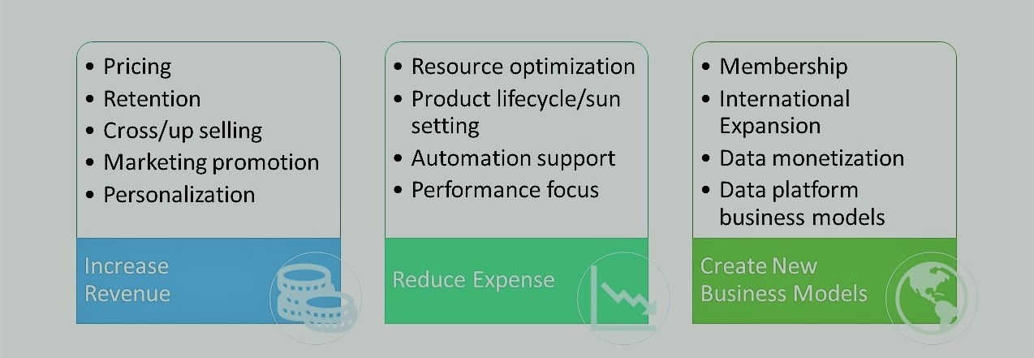

In disruptive markets, data is your rock. You can put member engagement strategies to the test by raising or lowering prices; investigate cross-selling and upselling and assess the impact of segmentation and augmentation. Careful analysis of the output can reveal how to create services that maximize revenue.

Associations seeking a broader membership base can explore scenarios for international or internal expansion, or discover how to monetize proprietary information. Most important, marketing automation adds the dimension of customization. There is the opportunity to provide individually curated content designed to meet highly specific needs.

Look Beyond Members

Robust analytics become critical as associations respond to dwindling engagement by creating a bigger tent. There is a trend toward expanding the definition of membership to include people who are on the periphery of the professional community. These groups are often defined as customers and viewed as having a limited interest in a long-term relationship with the association. Even member bases that are not growing in numbers are becoming increasingly diverse in race, ethnicity, and age. This variegated audience is conditioned to expect their business interactions to be highly responsive to individual needs and characteristics.

Williams notes: “Successful recruitment and retention initiatives will rely heavily on delivering value to each of multiple target audiences. For associations to remain relevant, the one-size-fits-all membership model must evolve. Groups that recognized this dynamic before the pandemic are, probably, in a better spot. Those who didn't shift to this strategy will be fighting to retain and recruit members.”

Lean Into Marketing
Williams emphasizes the significant role that marketing departments play in this effort: “Associations should consider their marketing teams as strategic partners. It's one of the few departments with a full line of sight across the organization. If the marketing team doesn't have influence and involvement in developing the strategic plan, there's a major disconnect, which results in missed opportunities. It is the job of marketers to listen to the customer and influence the organization’s strategy – new product offerings or enhancements,
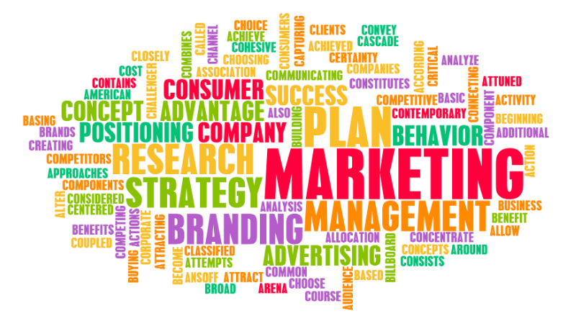
content, services, etc. Marketers are well-positioned to support the shift to viewing audiences as individuals.”
Marketing departments are strategic partners.

Associations tend to produce what they want members to have. Marketers can lead the charge in repositioning that thinking. Marketers use analytics, acumen, and evidence to guide the development of educational and product strategies toward customer-centric solutions. This concept is foundational to member engagement in the digital future.

Williams sees opportunity in taking a more expansive view of membership. She advises: “When you serve the industry as a whole, the possibilities for growth expand.” ​Studying where innovation is needed and what members want from their industry can open the door to partnerships that are both unexpected and mutually beneficial. But Williams emphasizes the importance of tying membership goals to strategy and creating meaningful experiences for a variety of customers.

“You must understand what quality engagement represents to each group,” Williams observes. “Some members may want to participate in governance, while others will be satisfied to read your magazine. Tracking where members fall on the ladder of engagement and being prepared to give them a boost up when they are ready is critical. Conversely, watching who is slipping and offering appealing incentives for re-engagement, is also important.”

Mass customization, which seems like an oxymoron, is already firmly established. Companies like Stitch Fix and Trunk Club have made individually curated fashion purchasing commonplace. Rice believes this strategy may hold promise for delivering meaningful member value: “In the future, it is possible that the dues structures will disappear,” she explains. “The potential exists for each member to create and procure the package of benefits that most closely fits their needs.”

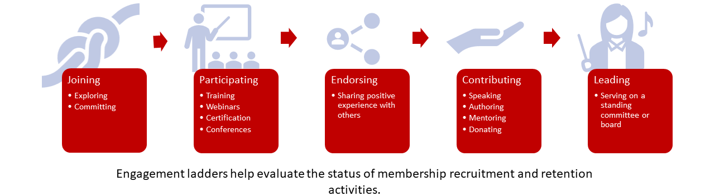

Seek Relevance
Until we have access to those sophisticated algorithms, Rice emphasizes the need for a thoughtful approach. “Because you can monitor a variety of behavior doesn’t mean that all that information is relevant. There is a danger in making engagement ladders, and similar tools, so complex that they are no longer useful. It shouldn’t require a degree in statistics or behavioral science to interpret the numbers. Dashboards should be easy to compare across the organization.

“As associations feel the pressure to increase value, there is also a tendency to build overly complex dues structures,” Rice advises. A better solution for growth is to carefully examine the organization’s priorities and determine where you can provide the greatest value to the most people. Considerations such as shared interests, experience levels, and preferred roles can be templates for categories and pricing.

Kim Robinson, CEO of FrontlineCo, notes: “The dues membership model, which has sustained associations for so long, is now in serious jeopardy. Yes, there are for-profit companies that have sponsorship or recurring revenue opportunities. I’m not sure that there will ever be a 100 percent transition away from dues, but associations can no longer expect that people will pay automatically. At a minimum, you’ve got to make the case for membership over and over again. Today, people will pay if they receive value. But value must be reestablished in every member transaction.”

Defining value becomes increasingly important in the face of growing competition. When Stephanie Mercado was hired as Executive Director at the National Association for Healthcare Quality (NAHQ), she focused the organization on defining its value proposition. Mercado acknowledges that while it’s tempting for associations to model their offerings after competing organizations, that approach is counterproductive. “NAHQ volunteers and members often send me information on training other groups are providing, suggesting NAHQ should do this too. I generally respond that the program is great for them, but that's not who we are,” she says. “We define, we teach, we certify. If we focus on being [other organizations], then somebody else will be us. We just need to be us and do that well in a very disciplined way.”

Build Community

Broadening the base is a good approach to generate new revenue. But the pitfalls of trying to be all things to all people are real. After spending limited resources to attract business, how do you increase the return on investment? Unless you convert fresh recruits into members who are loyal over time, it’s a bit like being a dog chasing its tail.

This is where the traditional triumvirate of mission, vision, and values delivers. A compelling cause can inspire loyalty, unite diverse factions and establish worth with a power that material benefits cannot duplicate.
A compelling cause inspires loyalty.

Brent Gibson, Chief Health Officer National Commission on Correctional Health Care and Managing Director NCCHC Resources, Inc., emphasizes how that organization uses mission to generate revenue: “Think about Newman’s Own brand and similar products. Running a business as a charitable endeavor is an effective selling point,” he advises. “People are happier to part with their money when they know that it’s being invested in a cause that is noble and good. At NCCHC Resources, we sell our technical services wrapped around the core of our long-standing mission. Our competition is in business to make money as a primary objective (and there is nothing wrong with that). But we serve our mission by operating profitably.”

ENA is another example of how a shared commitment builds loyalty and affiliation. “Emergency nurses can get education in a variety of formats,” MacRae notes. “So why come to us? It is about having a community of experts. Education is everywhere. But community is here at ENA—that’s the differentiator. I don’t think you can talk about one without the other. Only another colleague can walk in our members’ shoes. We provide the opportunity for them to share and get support from others and know that they are receiving best-in-class education and research. Of course, our services must continue to be engaging and meaningful. We also need to keep nourishing that sense of community. Burnout is huge in this profession. One way we can help is to make sure that our members are sharing their experiences.”

Maintaining that connection during the lockdown was a challenge that ENA met with humanity and humor. ENA hired a DJ and organized five themed virtual dance parties. It was a chance for members across the country to reconnect with each other and their association through music and movement.

Provide Purpose
Mission must be bigger than words. It needs to be a lively presence throughout your organization. Younger people are hungry for purpose in both their personal and professional lives. Associations that demonstrate that they are making the world a better place will find followers.
Shared learning generates participation.
“Associations are a natural fit for developing communities of practice,” Engel notes. “This concept was originated by cognitive anthropologist Jean Lave and educational theorist Etienne Wenger. Communities of practice are a three-legged stool, comprised of a shared domain of interest, relationship building through engaging in joint activities related to that domain, and learning that takes place through doing the work. Associations that consciously cultivate communities of practice will help individuals find connection and purpose within a diverse organization.”

As Chairman of the Board of Association Success Corporation, Amith Nagarajan is a serial entrepreneur whose family of companies is conceived around the idea that purpose should drive value. “Profit is important,” he notes, “but, purpose is deeper and more emotionally meaningful. Purpose-driven companies strive to solve problems that impact a broad swath of people, including groups who may be outside of the typical scope of their industries.”

Take time to talk with your most engaged members about the mission. Discover what purpose means to them and consider how you can expand on that value. It is never enough to tell. Showing creates believers. Put your mission on display and make it easy for people to get involved.

Open Opportunities for Participation
Finding purpose requires participation. If your organization has successfully attracted a new generation of members, don’t leave them sitting on the sidelines. Where leadership is a club defined by gray hair, personal connections, and closed minds, those newbies won’t be around for long. Engel advises: “As research both within and outside the association community clearly demonstrates, younger generations—Gen X, millennials, and Gen Z—are eager to contribute to organizations whose missions they support. They just have some different goals they’re looking to achieve through those contributions. Organizations that successfully evolve to meet those needs will find themselves benefitting from a community of eager volunteers.”

Williams agrees: “Associations must create opportunities for millennials and Gen Zers to be involved and build an organization that is valuable to them. Diversity and inclusion need to be represented at the board level and flow down.”

Make Chapters Count
Chapters can be fertile ground for growing community and purpose. But, this is typically a relationship between unequal partners. Success depends, in large part, on how willing or able the parent organization is to share resources and support. Where chapters feed members and revenue to the larger association, they are viewed as wunderkind. But if they are a drain on limited resources or difficult to manage, they are treated more like the eccentric relative who no one wants to admit is part of the family.

“Chapters can provide opportunities for leadership development, resume building, relationship building, contributing to a meaningful mission, and career advancement,” Engel advises. “If your members need these things—and they probably do—but there are no chapters, people may begin to organize on their own. On the other hand, as we become more accustomed to connecting on virtual platforms, location-based chapters may become less important as members seek to organize themselves around attributes that are more relevant to them than where they happen to live or work.”

Where relationships are fraught, strategy offers a solution. By including chapter representation in the planning process, creating buy-in, and committing the necessary resources, the entire organization can benefit. Promoting new ways of thinking is never easy, but maintaining a broken system is equally challenging. Your path depends on whether you choose to move forward or standstill.

Mirror the New Dynamic

That choice—whether to accept the challenges related to progress or to maintain the status quo, is the question that organizations face. Moving into a new decade, following a sustained period of enforced immobility, promises to reignite the urge to collaborate, convene, and participate. Associations must explore how to capitalize on this explosion of energy.

Serving a stale menu of initiatives and products will not be a match for the dynamic. Leaders must use technology, strategy, marketing, and mission to build community and provide purpose for a new generation. What association members want will be unique to each profession. Reflecting the diversity, innovation, and vitality of the digital era is the significant common denominator for success.

Introducing .orgCompanies

.orgCompanies is dedicated to supporting associations as they undertake transformational change. We offer strategic guidance, practical solutions, and access to a vibrant network of executives and education to strengthen associations and the value they provide. Three interrelated organizations form the .orgCompanies brand:

- .orgSource provides association leadership teams with strategies and data-driven solutions that reflect our deep understanding of the challenges that associations face and our knowledge about approaches to overcoming them. Our success spans fifteen years and represents more than 200 client engagements. From developing an integrated strategic plan to preparing your association for a digital future and supporting the implementation of your important projects and initiatives, .orgSource’s experienced advisors are ready to serve your needs.
- .orgCommunity connects members to a vibrant network of executives, entrepreneurs, and strategic partners dedicated to shaping the future of associations. Members have access to collaborative events, small group learning opportunities, and peer-to-peer counsel with trusted allies, mentors, and friends who share a passion for excellence.
- .orgFreelancer makes it easy for organizations and freelancers to connect and get work done. Our concierge service matches employers with qualified professionals that meet organizational and cultural needs. .orgFreelancer helps employers find specific expertise, short-term support to complete a project, or fill a temporary position.
Let us share .orgCompanies’ passion for designing premium solutions for associations. www.orgCompanies.com

