This is a paper I wrote for .orgSource related to the impact of COVID-19 on associations.

Blazing a Passage to Resilience
Managing Challenges and Identifying Opportunities During COVID-19

May 18, 2020

Copyright © 2020 .orgSource. All rights reserved

Contact:

Sherry Budziak, President

2033 Milwaukee Ave. Phone: 847.275.1840
Suite 324 Email: sherry@orgsource.com
Riverwoods, IL 60015 Web: www.orgsource.com

Contents

Introduction 3

Psychosocial and Economic Impacts of the Pandemic 4
Reaction—Short Term, Through August 2020 5
Communication, Empathy, Culture 5

Assessment—Mid Term, From September 2020 Through May 2021 6
Meetings and Education 7
Governance and Advocacy 8
Membership 9
Strategy and Planning 10
Scenario Planning 11
Decision Trees 11
Sponsorship 11

Renewal—Long Term, June 2021 and Beyond 12

New Beginnings 14

Appendix 15

Introducing .orgCompanies 18

Introduction
We thought the great disruption would come from cyberspace—that robots, AI, and other electronic innovations would be the agents of economic and social reinvention. But nature has flagrantly upstaged technology. In this new scenario, the villain, a virus, has been around longer than humans, and technology is wearing a white hat and saving the day.

Over the last three years, .orgSource has been investigating how Industry 4.0, or the intersection of the digital, material, and biological worlds will impact associations. Our goal was to help clients develop the adaptive culture and digital infrastructure needed to meet an unpredictable future. We believe that those tools and behaviors are also central to surviving a crisis like the one we are currently experiencing.

Early in our investigation, the technology revolution was not being considered extensively in the association community. Software systems were seen as an adjunct to separate lines of business rather than the fulcrum of operations and the library of organizational knowledge. This view probably still predominates.

To promote the importance of an integrated digital strategy and to understand how a variety of associations and professions were responding to disruption, .orgCommunity, our professional development organization, convened an executive Think Tank. During those meetings, the group shared information on how to lead, manage, and strategize in a rapidly changing environment.

From the Think Tank, we expanded our research to include in-depth interviews with our most farsighted colleagues. These conversations resulted in the Association 4.0™ books. Positioning for Success in an Era of Disruption outlines how 23 CEOs are growing and changing their organizations to meet an uncertain future. The companion book, An Entrepreneurial Approach to Risk, Courage, and Transformation, investigates this question from the perspective of business leaders in our community’s for-profit sector.

The following insights concerning how the association landscape will change as a result of COVID-19 and how executives can respond summarizes ideas gleaned from the Think Tank, our books, expert speakers who have presented at our conferences and webinars, as well as surveys and over 15 years of experience helping associations position for success.
Psychosocial and Economic Impacts of the Pandemic

Our recent dialogues concerning COVID-19 were characterized by contrasts. On the one hand, with 1.4 million people infected and a death toll nearing 100,000—fear prevails. In most hostile situations, the danger is visible. We have a good idea of how we need to respond to a hurricane and how great the threat will be to our lives and livelihoods.

The virus is a highly unpredictable, hidden enemy. Isolation is the only current guarantee of safety. These circumstances create choices that are at best challenging, at worst life-threatening, and unfailingly stressful. When routine activities such as buying groceries, gathering with friends, or eating in a restaurant seem fraught with danger, we are traveling in exceptional territory.

Coupled with psychological distress is the looming certainty of unprecedented economic reversals. Three million Americans filed jobless claims for the week ending March 21. The food supply chain in the United States is under threat from outbreaks of the virus at meat and poultry plants and travel, retail, and various manufacturing industries will certainly suffer tremendous losses. Some businesses are already being reshaped and others may never completely recover. Response to the virus has also highlighted deep political divisions in our country as well as widening social inequities.

From a more optimistic perspective, associations, which have been struggling for relevance, are now in the spotlight. They are mentioned consistently in the news as a source of knowledge and information. Some, especially those in the healthcare professions, discovered how to highlight their value and services early in the pandemic and will continue to build on those strategies over the coming months.

Associations have the unique ability to communicate across an entire industry and to reach diverse constituents. As the virus recedes, organizations that adjust, learn, and seize opportunity where they can find it have the possibility for increased recognition, greater efficiency, and new beginnings.

Both sides of this coin will play out against the digital revolution, climate change, and increasing cultural and economic polarization. The last great national catastrophe, September 11, 2001, permanently altered the way we work and travel. The psychological and economic pain of this event will do the same on a far more sweeping scale. That is probably the only assessment we can make with complete certainty.

Reaction
Short Term—Through August 2020

In just two months, this virus has profoundly changed the way we perceive our personal lives and our work. It has simultaneously stripped away the superficial, changed ingrained habits, forced us to look backward, pushed us to think forward, and kept us frozen in our tracks.

Communication, Empathy, and Culture

The short term is a period of reaction and contraction with a laser focus on the immediate operational and financial needs of the organization. There is no time for superfluous programs or activities. Leaders can use their soft skills to make a significant positive impact. Empathy with those who are challenged by isolation or overwhelmed with frontline service, transparent communication about the association’s status, and immediate adaptation to current circumstances is critical.

Stefanie Reeves, Executive Director of the Maryland Psychological Association advises, “Communicate, communicate, communicate! COVID gave MPA the opportunity to showcase benefits members may not have been aware of, including a resource toolkit for practitioners, which featured information on transitioning to telehealth.”

Sharon Rice, .orgSource’s Managing Director Business Strategy, emphasizes the importance of retaining the human connection despite physical separation. “In the best of times, engagement is predicated on a strong understanding of your members, their professional lives, their goals, and challenges. While I am a big proponent of leveraging data to achieve this understanding, in times of crisis, nothing can replace actually talking to as many members as staff and leaders can. Ask them what they are facing and how the association can better meet their needs. Let them know that you are there for them. If you can formalize this as an activity, take notes that can be reviewed. You will discover ideas to act on in both the short and long term.”

For employees who are not accustomed to working from home, a strong organizational culture and vision will support them as they cope with the stress of isolation and the additional challenges associated with homeschooling, and caring for children.

Where culture has not been a priority, the struggle will be more acute. We are venturing into uncharted territory. No one knows how the next weeks and months will unfold. Don’t let anxiety about work contribute to your team’s stress level. Quickly establish guidelines and a process for how you will conduct business. As much as possible, involve the group in creating your policies.

A crisis strips the veneer off business as usual. Underlying strengths or weakness of operational systems—technology, finance, governance, and human resources—are starkly revealed. Jeff De Cagna, Executive Advisor at Foresight First, urges leaders to approach the future with brutal honesty. “Short-term pessimism is the only responsible mindset for association decision-makers. Staff and volunteers must operate with a clear-eyed and sober perspective on what is happening right now and what will happen over the next 12-24 months and beyond. The pessimistic mindset forces us to deal with facts and information and brings discipline and focus.”

Leaders will need the courage to confront disfunction and, where possible, to implement change. For organizations that have been limited by bureaucracy or outdated policies, the disruption may present an opportunity to initiate more efficient channels for decision-making and to correct the alignment of board and staff responsibilities.

Stefanie Reeves noted that MPA was able to capitalize on its ability to provide quality just-in-time education. “We created a COVID webpage and held a webinar for all psychologists on how practice can be conducted under a stay-at-home order. A former member who was impressed with the content rejoined because `I felt guilty not paying for it [the content].’ Providing quality, on-time information in the short term will help associations in the long term.”

Abe Eshkenazi, CEO of the American Production and Inventory Control Society, stresses the need to treat the short-term period like a turnaround He advised quick, decisive action and:
- Clinging to what you do best
- Preparing for the crisis today and considering what you will do when it begins to abate
- Focusing on the products and services that preserve and generate cash

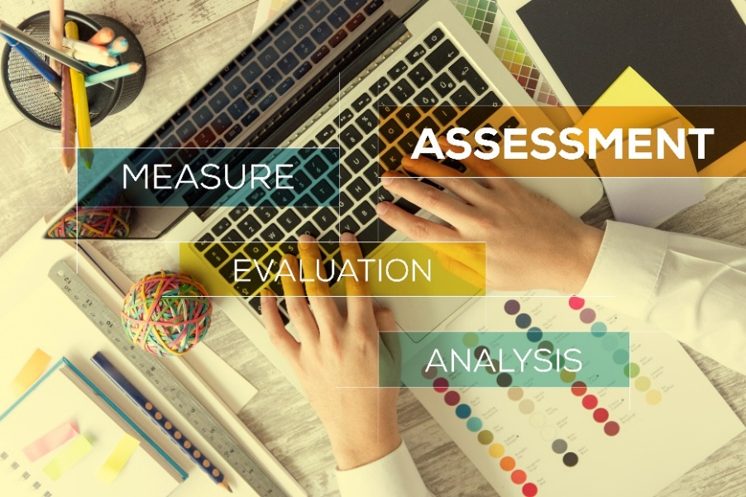
Assessment
Mid Term—From September 2020 Through May 2021

The midterm is a period of assessment, dialogue, and gathering information to guide the future. Trust has either been enhanced or diminished based on the quality of the communication and responsiveness of the management team to short-term challenges.

By now, there should be a good understanding of the association’s financial status and long-term viability. Organizations should have explored strategies for managing cash flow. Spending reserves, securing a line of credit, cutting expenses, or some combination of those options, will be in place. Financially vulnerable organizations may have established partnerships with other associations or for-profit companies to sustain operations.

Hard decisions concerning staffing may be on the horizon. If furloughs or layoffs are necessary, prepare by having information in place to support employees. Follow the procedures outlined in your employment policies and act with fairness, transparency, and compassion.

If programs or activities were suspended during the short term, it is a good time to evaluate their future. Are they important to member engagement or a drain on the organization’s resources? Consider expanding the activities that deliver the greatest member value and discontinuing poor performers. Frank conversations with the board can help to jump these hurdles and could open the door to more candid future dialogues.

Stabilization should be slowly occurring as staff become accustomed to new work styles and supervisors have a better understanding of how to motivate and manage their teams. As a consequence of remote work and outsourcing, some organizations may reevaluate their future staffing patterns as well as their need for office space.

Above all, perspectives will have shifted. Among the activities that will be seen through a new lens are:

Meetings and Education

Most associations didn’t jump on the virtual meeting bandwagon until the music was about to stop. The annual, big-tent blowout was still the king of revenue for many groups. Unfortunately, associations with limited reserves, which canceled that event, may suffer lasting consequences.

We have learned the importance of a diversified portfolio the hard way. Associations that are not planning a virtual conference are, at least, investigating the mechanics and considering how online gatherings could be incorporated into their communities.

Society for Academic Emergency Medicine
For Megan Schagrin, CEO of the Society for Academic Emergency Medicine, translating the annual meeting to a virtual environment was an easy decision. SAEM members are on the frontlines of the pandemic. They risk their lives every day. Some have fallen ill themselves. “We see ourselves as a behind-the-scenes piece in this fight,” says Schagrin. “We know that we must support our members by providing the education they need. With the exception of social events, all meetings and all presentations will happen in a virtual format. We wanted to ensure that our members didn’t miss an important opportunity for their professional promotion.”

American Association of Clinical Endocrinologists
The American Association of Clinical Endocrinologists took another tack. They made the decision to cancel the May annual meeting. Elizabeth Lepkowski, Chief Learning Officer, explains, “Our physicians treat the patients at highest risk for COVID-19. They are extremely busy assessing how to deliver virtual care and consulting with their ICU colleagues on COVID patients with diabetes or other endocrine disorders. Many of the planned plenary speakers were international and the issue of time zones didn’t make it practical to try and organize a virtual meeting.” AACE offered 80 percent of the meeting content on demand via the learning management system. Live webinars are also planned for the evenings when physicians have more time to participate, and Master Class Monday, a new series of packaged learning experiences, is being launched.

Many groups are also looking at the possibility of organizing multiple, smaller local events. This approach could reinvigorate chapters and components, which had been falling out of favor for several years.

Bite-size learning, once a growing trend, maybe suspended while people are homebound and craving more immersive experiences. Some groups are organizing virtual town meetings and forums. These are an opportunity to gather real-time information on member needs. As associations grow more adept with the technology and members become more accustomed to the remote format, future meetings may routinely include a combination of virtual and in-person activities and presentations.

Associations that are unfamiliar with virtual events should exercise prudence and caution in vendor selection and implementation to ensure that members have a positive first experience.

Learn more about strategies for virtual events and hear a panel discussion featuring Chagrin, Lepkowski and Jennifer Pitts, Senior Director of Products and Programs at the National Association for Healthcare Quality.

Governance and Advocacy

Government affairs professionals may find themselves with an increasingly significant role to play as public policy develops around workplace and health issues. The American Medical Association’s COVID Advocacy Progress Report demonstrates that group’s vigorous efforts to improve work, safety, education, and finances for its members. The American Lung Association launched a major effort to expand research, generate funding, and heighten awareness related to respiratory viruses. All associations have a unique opportunity to provide and disseminate information and guidance concerning new work methodologies such as telemedicine and relevant workplace safety considerations.

At this point, if there are internal governance structures that prevented a quick response, they will have been on full display. Use lessons learned as an opportunity to explore the more fluid leadership styles that enable organizations to adapt to changing circumstances. Review the bylaws to update and revise provisions that impede effective governance or require groups to meet in person to conduct business.

Membership

Massive unemployment, lost productivity, and salary reductions will impact how both industry and individuals view the relevance of association membership. Groups that were able to quickly provide members with helpful resources may see a resurgence in engagement. Those who were slow to respond may experience significant declines, especially as members prioritize their time differently.

Many of the leaders who we interviewed for our books advocated for a more inclusive view of membership and cautioned that by clinging to traditional definitions, associations are setting themselves up for future failure.

Since day one as CEO of HIMSS, H. Stephen Lieber embraced the idea of a bigger canvas. His vision grew HIMSS out of its traditional roots and into one of the nonprofit industry’s most forward-looking organizations. Lieber shifted the association’s focus away from membership and toward reaching, influencing, and serving as many people as possible. He believes, “This is one of the fundamental changes associations need to go through. Associations need to move away from limiting terminology that causes people to work in an old model and old way of thinking.”

If the pandemic has revealed professionals outside your industry who are seeking the information and services that your organization provides, cultivate their interest. Along with creating growth, curate value. Kim Robinson, CEO of Frontline Management, advises: “The dues membership model, that has sustained associations for so long, is now in serious jeopardy. Yes, there are for-profit companies that have sponsorship or recurring revenue opportunities. I’m not sure that there will ever be a 100 percent transition away from dues, but associations can no longer expect that people will pay automatically. At a minimum, you’ve got to make the case for membership over and over again. Today, people will pay if they receive value. But value must be reestablished in every member transaction.”

Defining value becomes increasingly important in the face of extreme distraction and growing competition. When Stephanie Mercado was hired as executive director at the National Association for Healthcare Quality, she focused the organization on defining their value proposition. Mercado acknowledges that while it’s tempting for associations to model their offerings after competing organizations, that approach is counterproductive. “NAHQ volunteers and members often send me information on training other groups are providing, suggesting NAHQ should do this too. I generally respond that the program is great for them, but that's not who we are,” she says. “We define, we teach, we certify. If we focus on being [other organizations], then somebody else will be us. We just need to be us and do that well in a very disciplined way.”

Another strategy to diversify revenue and prepare your association to weather future disruption is to look away from who is qualified to be a member and toward where your organization might fill gaps in service and meet critical needs.

Read profiles of H. Stephen Lieber and Stephanie Mercado in Association 4.0: Positioning for Success in an Era of Disruption. Read Kim Robinson’s profile in Positioning for Success: An Entrepreneurial Approach to Risk, Courage, and Transformation.

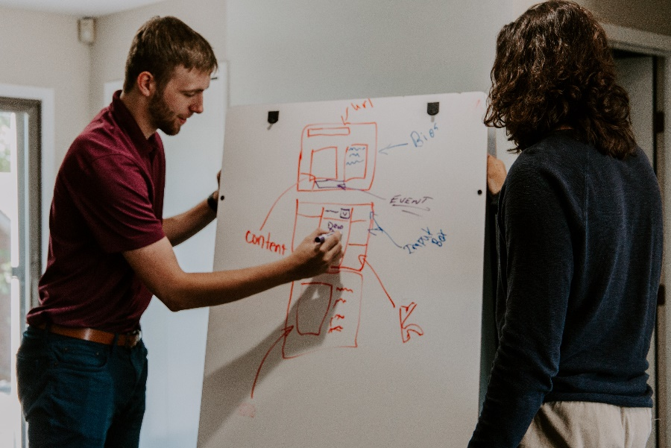
Strategy and Planning

The most innovative associations were already rejecting the traditional strategic planning process as too narrow and rigid for the digital marketplace. The pandemic highlights the need for targeted decision-making tools as well as an integrated approach to long-term strategy that cuts across the entire organization and includes a technology assessment and financial requirement as a critical component.

When asked about planning during and post COVID-19, Sharon Rice offered this advice: “During a crisis, focus needs to be on the short term. It is highly unlikely that even the most well-conceived strategic plan, crafted before the pandemic, is going to be useful to navigate 2020 and beyond. In addition, while we can project how COVID-19 is going to change our world, it will be a while before we are on firm enough ground to engage in anything resembling long-term planning. Focusing your efforts on scenario planning will benefit your organization in a way that trying to follow a strategic plan cannot. It is a highly disciplined form of planning that is also responsive to the environment. I do think long-term plans will be important post-pandemic, but I doubt they will resemble the plans we have been creating for decades. That formula will be archaic.”

Stefanie Reeves agrees: “With so much uncertainty, it’s very easy for boards to cling to what has worked and hope that everything will work out. We need to plan for multiple scenarios that may not fit neatly into a strategic plan model and that will be a hard lift for some boards. However, it presents a great opportunity for creativity, not only in what we’re planning, but how we’re doing it.”

Jeff De Cagna offers the contrarian view that strategic planning is no longer an effective tool. “There will be no going back to the pre-pandemic world, and no business-as-usual going forward,” he says. “It is critical for association staff and voluntary decision-makers to free themselves of their orthodox beliefs, including those embedded in current strategic directions. Under ordinary conditions, the strategy window is a maximum of 36 months. The COVID-19 pandemic has irrevocably altered the trajectory of that time horizon, as well as all successive iterations throughout this decade. My guidance to boards, chief staff executives, and other decision-makers is to rid themselves of strategic planning once and for all and concentrate instead on building new capacity for strategy as a process of learning with stakeholders and learning as much as possible about the future through the practice of foresight.”

Scenario planning and decision trees are among the tools .orgSource uses to help clients identify solutions to challenging problems.

Scenario Planning
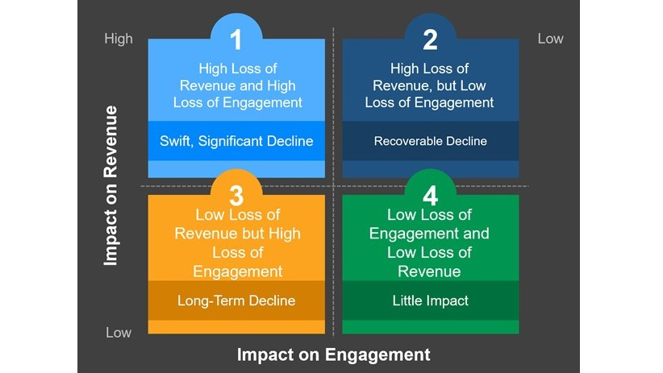
“The most important thing about scenario planning,” Sharon Rice notes, “is that it gives us direction, and that’s what we’re looking for in an acute situation.”
Possible scenarios during COVID-19
The process revolves around these six core questions:
- Why are we engaged in planning now?
- What are the factors that are driving uncertainty and how impactful could they be?
- What are the potential short, mid, and long-term impacts?
- What are the possible scenarios we are facing?
- What key indicators will show that we are moving closer to a scenario?
- What will the operating strategy be for each scenario?

Decision Trees
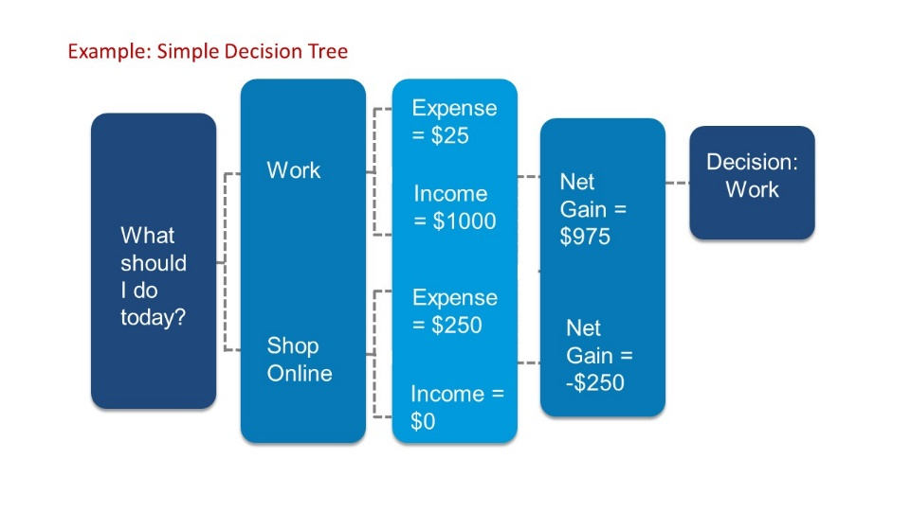
Decision trees are a tool that the business world co-opted from computer programmers. They are a graphic framework that uses estimates and probabilities to project the likely outcomes and net gains of various alternatives. Decision trees are built from tables or matrixes that are illustrated in a branch format. They are easy to create but it bears remembering that they are also only as good as the estimates used in the calculations. “A key thing about decision trees is there have to be alternatives,” Sharon Rice says. “You must be seeking to evaluate several options.”

Sponsorship
A more creative, collaborative approach to sponsorship will be needed as companies begin to reassess their relationships with associations. Over the last few years, there has already been pullback from sponsorship; if associations are unable to offer value that impacts the bottom line, this decline in non-dues revenue will continue.

Renewal
Long Term–June 2021 and Beyond
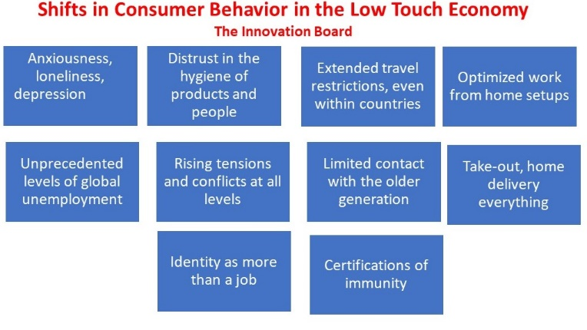
For the economy and country to survive, business must resume. But without a vaccine, the virus will continue to be with us. To avoid scenarios as devastating, or worse, than the outbreaks that occurred in New York and Italy, social distancing will become a way of life for the near, and possibly, the longer-term future. We are moving into a new Low Touch Economy. At this point, it is impossible to know what impact that will have on various industries and on the country’s overall ability to recover. However, it is certain that if the pandemic had occurred 20 years earlier, before smartphones and virtual connectivity, the consequences would have been much darker. It is not an exaggeration to say that if technology was changing the landscape three months ago, it is now the glue that is holding both economic and social relationships together.

The “Lazy Economy,” exemplified by Amazon Prime Now, the app that in a click or two finds products that can be delivered to your location within the hour, was already creating an expectation for hyper-convenience and accessibility. The Low Touch Economy which adds the need for safe, on-demand but at-a-distance, products and experiences accelerates that expectation. The Board of Innovation, a global strategy firm, identifies 10 shifts that characterize behavior in the era of COVID.

Ironically, as we are required to physically distance, an intimate understanding of members’ and customers’ needs is more important than ever. Associations will be challenged to create relevance and value in this cautious, yet increasingly individualized consumer environment. Using data and analytics to access that deep level of customer awareness and understanding of how to deliver knowledge, products, and information seamlessly will be critical in the Low Touch Economy.

Associations will need to abandon their reliance on tradition and adopt an approach that is innovative and transformational. New styles of leadership and different organizational structures will be required, not only to manage the speed of business, but to remain viable. To navigate a marketplace driven by technology, CEOs will need to be as comfortable in cyberspace as they are in the boardroom. Mastery of digital business practices and an agile mindset will be required to thrive in the midst of rapid change. Leaders must reinvent themselves in these and many other ways:
- Commit to innovation, growth, and professional development
- Be passionate problem-solvers who are never satisfied with the status quo
- Forcefully communicate vision throughout the organization
- Abandon hierarchy for more networked, flexible teams that collaborate freely
- Be outward focused and keen observers of the market and its consumers
- Understand how to manage remote workgroups and utilize freelance talent

Although our books were written well before the pandemic, these comments on leadership from contributors are relevant to the world we currently face:

“Based on our research and experience, the more global perspective starts at the top. The digital age is all about leadership. It is the style of the CEO and executive team that drives the governance and the culture. Jim Collins advises—get the right people on the bus and the rest will take care of itself. You can have the best governance model, but with the wrong people on the team, you won’t be successful.” Hugh Lee, Co-Founder, Fusion Productions

“Many people believe that associations should run more like businesses. The reaction to that has been to hire a CEO from the corporate sector. But future success really is not about profit and loss. I think it depends on operating as efficiently and cleanly as possible, in other words, being entrepreneurial. Steve Blank, who is a Stanford University professor and the author of The Lean Startup, proposes a business approach that offers a lot of value for the future. His methodology is characterized by experimentation, openness to customer feedback, and product and systems design that is iterative, as opposed to static.” Tim Ward, Co-Founder, Gravitate Solutions

“Those who want to fight over a shrinking pie—I let them go for it. I’m not interested. If there is an information product, a marketplace, or a customer base of use to both of us, then let’s find ways to partner and make it commercially viable.” David Schutte, CEO, SAE Group

COVID-19 has obliterated the status quo. We are on notice that complacency is a recipe for failure. The digital marketplace demands that you let go of the past, challenge current assumptions, and lead with what’s next. It’s not an easy proposition. But when you integrate technology into your leadership style and your culture, you have a powerful partner that keeps the focus where it should be, on your members and the marketplace.

Read profiles of Hugh Lee and Tim Ward in Association 4.0: An Entrepreneurial Approach to Risk, Courage, and Transformation. Read a profile of David Schutte in Association 4.0: Positioning for Success in an Era of Transformation.

New Beginnings

With knowledge and experience managing the virus, we will stand on firmer ground. There will be an opportunity to reimagine business in light of lessons learned and changes we have been forced to make. Associations will become more resourceful and adaptive. As leaders in digital strategy and transformation, .orgSource can help you build the skills, tools, and behaviors to position your association for success today and in the future.

APPENDIX
Short, Mid and Long-Term Impacts of COVID-19 on Associations
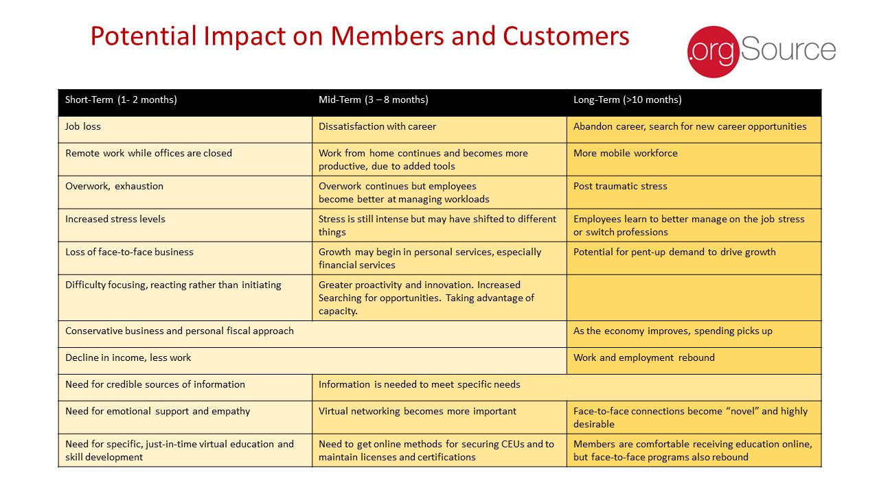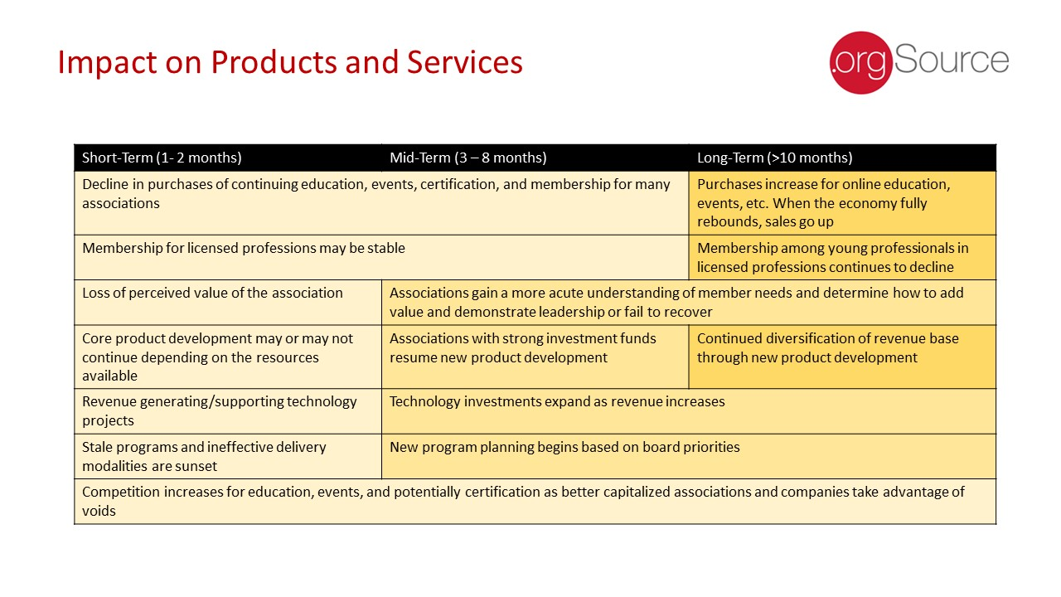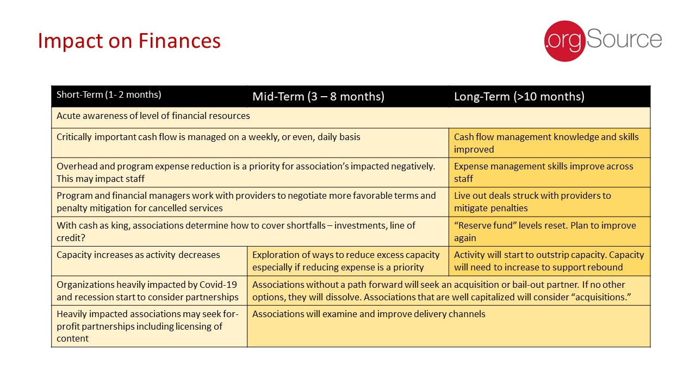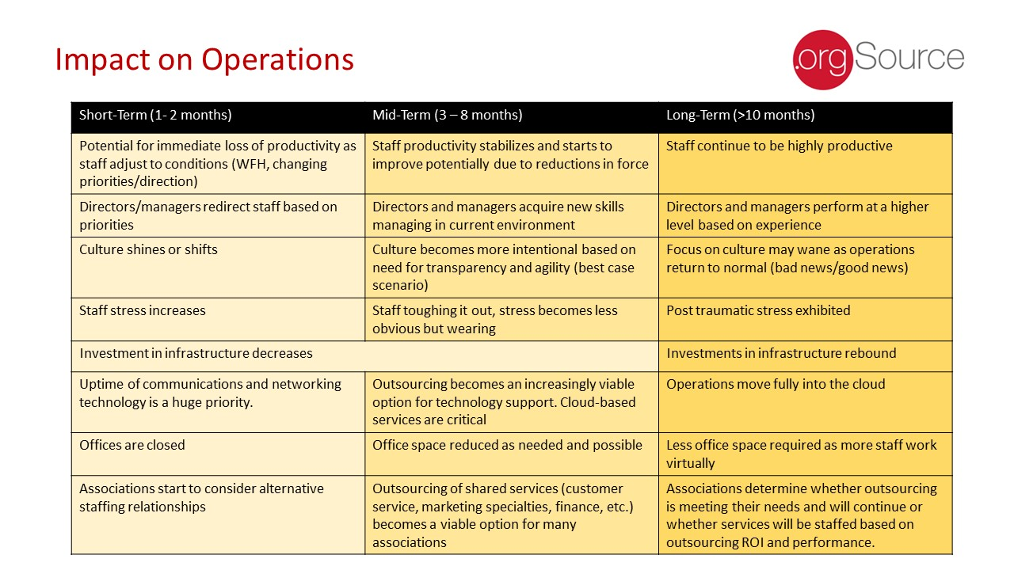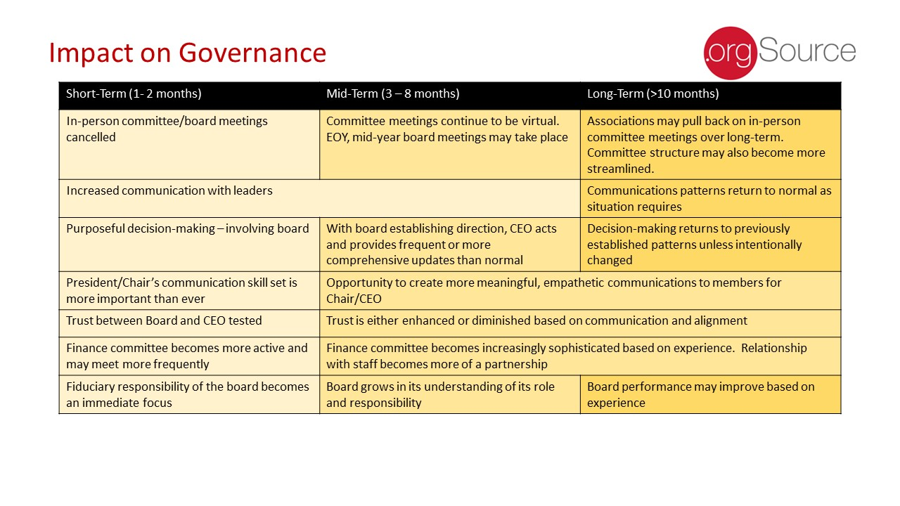

Introducing .orgCompanies

.orgCompanies is dedicated to supporting associations as they undertake transformative change. We offer strategic guidance, practical solutions, and access to a vibrant network of executives and education to strengthen associations and the value they provide. Three interrelated organizations form .orgCompanies brand:

- .orgSource provides association leadership teams with strategies and data-driven solutions that reflect our deep understanding of the challenges associations face and our knowledge about approaches for overcoming them. Our success spans fifteen years and represents more than 200 client engagements. From developing an integrated strategic plan to preparing your association for a digital future and supporting implementation of your important projects and initiatives, .orgSource’s experienced advisors are ready to serve your needs.
- .orgCommunity connects members to a vibrant network of executives, entrepreneurs, and strategic partners dedicated to shaping the future of associations. Members have access to collaborative events, small group learning opportunities, and peer-to-peer counsel with trusted allies, mentors, and friends who share a passion for excellence.
- .orgFreelancer makes it easy for organizations and freelancers to connect and get work done. Our concierge service matches employers with qualified professionals that meet organizational and cultural needs. .orgFreelancer helps employers find specific expertise, short-term support to complete a project, or fill a temporary position.
Let us share .orgCompanies’ passion for designing premium solutions for associations.
www.orgCompanies.com

